

CDBG DISASTER RECOVERY PROGRAM
Special Allocation of the Community Development Block Grant (CDBG) Program

Disaster Recovery Public Infrastructure Component
Application Guidebook and Forms

Funded by the U.S. Department of Housing and Urban Development’s (HUD)
Community Development Block Grant (CDBG)
Title I, Housing and Community Development Act of 1974 (42 U.S.C. 5301 et seq.).
Regulations 24 CFR part 570.

The Illinois Department of Commerce and Economic Opportunity (Department) is requesting applications for the CDBG Disaster Recovery Public Infrastructure Program (DRPI) from communities determined eligible under the CDBG Disaster Recovery Program. The Department is authorized to grant project funding for water/sewer systems, storm drainage systems, levee systems, and roads and bridges located in flood prone areas and/or areas substantially damaged as a result of flooding and storm damage between 2011and 2013.

For further information, contact:
DCEO Office of Community Development
217-785-6174
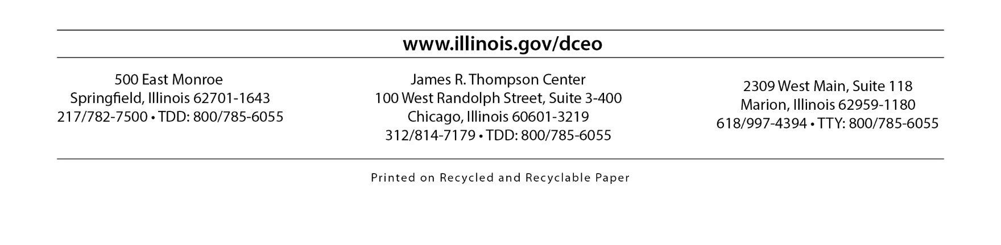
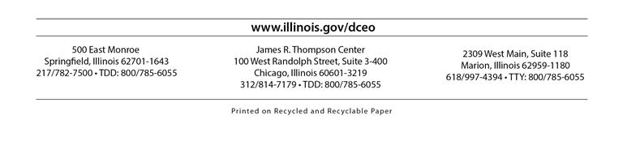
TDD: 800-785-6055
TABLE OF CONTENTS

PAGE

SECTION I: DISASTER RECOVERY PUBLIC INFRASTRUCTURE PROGRAM
Introduction 1
Important Notice 2

SECTION II: GENERAL APPLICANT INFORMATION
Federal and State Program Objectives 3
A. Funding Availability 4
B. Eligible Applicants 4
C. Eligible Activities 5
D. Ineligible Activities 5
E. Application Review and Evaluation Process 5
F. Applicant Information 6
G. Technical Assistance 6

SECTION III: PROGRAM INFORMATION AND POLICIES

A. Low-to-Moderate Income Requirements 7
B. Citizen Participation 8
C. Applicant/Grantee/Recipient Disclosure 9
D. Administration 9
E. Disaster Recovery Requirements. 9
F. State and Federal Compliance Areas 10
G. Initial Grantee Responsibility 11

SECTION IV: CDBG DISASTER RECOVERY COMPONENT REQUIREMENTS AND REVIEW CRITERIA

A. Threshold Criteria 13
B. Criteria for Selection 14
C. Application Review 15
D. Special Requirements 16
E. Eligibility Thresholds 18
F. Submission Information 18

SECTION V: APPLICATION FORMS, OTHER DOCUMENTATION

A. Application Forms
CDBG Disaster Recovery Public Infrastructure Application Checklist/Table of Contents 21
Sample Transmittal Letter 22
Applicant Project Information 23
Project Summary 26
Project Budget 27
DCEO Standard Grant Application 28
Project Maps 36
Project Readiness Summary 37
Sample Private Property Easement Documentation 38
Analysis of Benefit to Low-to-Moderate Income Persons 39
Low-to-Moderate Income Survey Summary 40
Income Survey Worksheet to Calculate Low-to-Moderate Income (LMI) Percentage Using Section 8 Income Guidelines 41
Income Survey Cover Sheet 44
Income Survey Form 45
Minority Benefit/Affirmative Housing Statement 46

C. Documentation, Certifications and Resolutions
Sample Council Resolution of Support 48
Sample Resolution for Meeting Urgent Need National Objective 49
Sample Resolution Committing Local Funds 50
Sample Public Notice and Public Comment Period 51
Applicant Certifications 52
Applicant/Grantee/Recipient Disclosure Certification 54
Certification of Exemption for HUD Funded Projects 58
Compliance Documentation Checklist (24 CFR 58.6) 59
Sample Intergovernmental Cooperation Agreement 60

SECTION V: ATTACHMENTS

A. HUD Section 8 Income Guidelines 59

B. Applicant Financial Information 70

C. Engineer’s Cost Estimate 71

D. Illinois Disaster Declarations 72

E. Meeting and Documenting National Objectives 77

SECTION I

Disaster Recovery Public Infrastructure Program

INTRODUCTION

The Disaster Relief Appropriations Act, 2013 (Pub. L. 113-2, approved January 29, 2013) (Appropriations Act) made available $16 billion in Community Development Block Grant (CDBG) funds for necessary expenses related to disaster relief, long-term recovery, restoration of infrastructure, housing, and economic revitalization in the most impacted and distressed areas resulting from a major disaster declared pursuant to the Robert T. Stafford Disaster Relief and Emergency Act of 1974 (42 U.S.C. 5121 et esq.) (Stafford Act), due to Hurricane Sandy and other eligible events in calendar years 2011, 2012, and 2013.
Subsequent to the Act, on December 16, 2013 a Federal Notice was published (Federal Register Volume 78, No. 241) that built upon the requirements of the aforementioned Act and advised the public of a $128,500,000 allocation for the purpose of assisting recovery in the most impacted and distressed areas in Colorado, Illinois and Oklahoma declared a major disaster in 2013. The Appropriations Act requires funds to be awarded directly to a State, or unit of general local government. In addition, The Appropriations Act requires funds to be used only for specific disaster recovery related purposes. The law also requires that prior to the obligation of funds, the State must submit a plan detailing the proposed use of funds, including criteria for eligibility and how the use of these funds will address disaster relief, long-term recovery, restoration of infrastructure, housing and economic revitalization in the most impacted and distressed areas. Detailed information on the unmet needs assessment, and planned programs by the State to meet those needs are included as part of the 2014 Disaster Recovery Action Plan.

The Disaster Recovery plan and other related updates can be found on DCEO's website at:

http://www.illinois.gov/dceo/CommunityServices/DisasterRecovery/Pages/2013CDBGDR.aspx

The purpose of the Disaster Recovery Public Infrastructure Application Guidebook is to provide guidance to the Applicant who is applying for disaster recovery funding through the Illinois Disaster Recovery Public Infrastructure (DRPI) Program administered by the Illinois Department of Commerce and Economic Opportunity (DCEO).

DCEO worked closely with the Illinois Emergency Management Agency (IEMA), the Illinois Housing Development Agency (IHDA), and obtained input from communities, individuals, and other interested parties to develop the State of Illinois Action Plan and Amendments. The State of Illinois Action Plan and Amendments outline the eligible activities and programs available to assist communities to meet unmet housing, business, public infrastructure, and other needs resulting from the 2011-2013 disasters. The plan allocates $6,800,000 for short and long term public infrastructure recovery through the DRPI Program. The purpose of this guidebook is to solicit applications for these public infrastructure funds.

Each application received by DCEO will be evaluated in accordance with a pre-determined project evaluation system based on the criteria identified in the above mentioned action plan. This system is intended to objectively, equitably and consistently evaluate all applications received. Further, it ensures that all proposed projects address only eligible activities and meet the requisite Requirements of the CDBG-DRPI Program. The projects selected must be approved by the Director of the DCEO.

The following sections provide an overview of the Illinois CDBG-DRPI Program which includes program background information, eligible applicants, national objectives, eligible activities, and applicable federal regulations and program rules. The Disaster Recovery Public Infrastructure Program Application Guidebook also includes the application schedule and information about the application screening, evaluation and selection methodology.

Most importantly, the Application Guidebook includes the application instructions that describe and explain the documentation that must be provided to properly quantify, qualify, and substantiate the proposal, as well as the Application Forms to be used by the Applicant.
The State estimates more than $40 million in public infrastructure damage requiring short term recovery assistance exists in counties declared under Federal DR-4116, DR-4157, DR-1991 and DR-1960. To address this damage, the State has received approximately $35 million in emergency response and immediate recovery assistance through funds made available through Federal Emergency Management Agency (FEMA). The difference remaining after FEMA funding is approximately $19 million which represents the current unmet, short term financial needs identified in the affected counties to date. Additionally, to address the short term needs, the supplemental appropriation also will support impacted communities in long term disaster mitigation strategies to avoid the level of damage and serve impacted communities. Attachment D lists the affected counties and illustrates the estimated financial impact of the damage to public infrastructure/facilities in counties declared under the aforementioned declarations. The extent of the impact to affected areas in Illinois in 2011, 2012, and 2013 made the State one of several eligible for this disaster recovery assistance to address both short and long term recovery, restoration and mitigation needs in these counties.
The CDBG-DR public infrastructure program will support projects that FEMA or other sources cannot fund, but which are nevertheless critical to recovery. Examples include water/sewer systems, storm drainage systems, and levee systems damaged by storm/flood in 2011, 2012, and 2013. In addition, roads and bridges needing immediate, short term repair/restoration or which can support long-term flood/storm mitigation efforts.

IMPORTANT NOTICE

Please read all of the enclosed materials carefully prior to preparing the application. In order to be considered for funding, applications must satisfy the threshold criteria before the application will be evaluated.

The open application period begins on Thursday, June 4, 2015 and will remain open until funds are fully allocated. As mandated, all CDBG DRPI funds must be fully spent by June 30, 2016. DCEO may request additional information as needed and promulgated by the CDBG-DRPI Program rules to comply with the State Action Plan and Amendments.

SECTION II

Federal and State Program Objectives

The Community Development Block Grant (CDBG) Program was established by the federal Housing and Community Development Act of 1974 (Act). Administered nationally by the U.S. Department of Housing and Urban Development (HUD), the Act combined eight existing categorical programs into a single block grant program. In 1981, Congress amended the Act to allow states to directly administer the block grant for small cities. At the designation of the Governor, the Department of Commerce and Economic Opportunity (Department) assumed operation of the State of Illinois CDBG – Small Cities Program in the same year. The Illinois block grant program is known as the Community Development Assistance Program (CDAP). Through this program, funds are available to assist Illinois communities to meet their greatest economic and community development needs, with an emphasis upon helping persons of low-to-moderate income.

To ensure that the state-administered program meets the intent of the federal Housing and Community Development Act of 1974, as amended, Congress has required that state-administered programs meet at least one of the following three national objectives:

Benefiting low-to-moderate income (LMI) persons; or
Aiding in the prevention or elimination of slums and blight; or
Meeting other community development needs that pose a serious and immediate threat to the health and welfare of the community.

To complement these federally-mandated objectives, the State has established the following specific objectives for CDBG-funded projects:

Strengthened community economic development through the creation of jobs, stimulation of private investment and strengthening the tax base;
Improvement of public infrastructure and elimination of conditions which are detrimental to health, safety and public welfare; and
Conservation and expansion of the State's housing stock in order to provide a decent home and a suitable living environment for persons of low-to-moderate income and the developmentally disabled.

Within the statutory requirements of the Act, Illinois has the flexibility to design its own program objectives and procedures for program administration and to develop criteria for selection of grant recipients. The Department administers a variety of CDBG-funded financial assistance programs which have been designed to meet locally defined community needs.

GENERAL APPLICANT INFORMATION

A. Funding Availability

Illinois' 2015 CDBG allocation for the CDAP programs has been determined by HUD to be $26,188,994. A special allocation of $10,400,000 for CDBG Disaster Recovery has been issued. Of this amount, $6,400,000 is currently available for CDBG-DR Public Infrastructure projects. These allocations are being used as the basis for the budget below.
Each program component has a maximum funding level or grant ceiling. While grant ceilings establish the upper limits that may be requested, individual grants are invited only in amounts commensurate with requirements of the proposed project. Fund availability will be distributed as follows:

Program Category | Budget | Grant Ceiling | Application  Dates
Ongoing CDAP (non-competitive) Programs
Economic Development (ED) | 2,000,000 | $750,000 | NA
Emergency Public Infrastructure (EPI) | 2,803,325 | $200,000 | NA
CDBG Special Allocation
Disaster Recovery Public Infrastructure (DRPI) | 6,460,000 | $600,000* | NA
CDAP Competitive Programs
Public Infrastructure | 14,000,000 |  | 07/08/2015
Public Infrastructure – Construction Only (PI) |  | $450,000
(No less than $1.5m awarded for Rural Water projects)
Public Infrastructure with Design Component (PI+DE) |  | $450,000
(No more than $150,000 in design costs, per grant)
Housing Rehabilitation | 6,500,000 | $400,000 | 07/08/2015
HUD regulations provide that three percent (3%) of the allocation plus $100,000 can be used for administration and technical assistance of established CDAP program components. Further, HUD allows five percent (5%) of the CDBG Disaster Recovery allocation to be used for administration and technical assistance in relation to the DRPI program component. In case of emergency, the Department reserves the right to change allocations to address specific needs of the communities affected.

*The Department reserves the right to increase the maximum award based on the unique aspects of circumstances surrounding a project application.

B. Eligible Applicants

Only units of general local government (i.e., cities, villages, townships and counties) within Illinois counties identified as federal disaster areas as a result of the disasters that occurred in 2011, 2012, and 2013, and that received a federal designation of “public assistance” may apply. See Attachment D for maps of disaster declarations and qualifying counties. Note that all communities identified, excluding the City of Chicago, and Cook and DuPage Counties may apply for DRPI funding. Two or more eligible local communities working in support of a single or collaborative project may also apply. (See Section V of this application guide for a sample cooperation agreement.) Local governments, however, must not only share a common problem, but must be able to demonstrate that a joint effort is required to solve the problem. Joint applications which are submitted only for administrative convenience will not be accepted.

Units of general local government may also submit "on behalf of" applications for local entities that otherwise may not be eligible to apply, including a water district or sanitary district.

Additional information concerning eligibility requirements for CDBG-funded programs can be found in the Housing and Community Development Act of 1974, as amended, (24 CFR Part 570) Section 105 (a)(2).

C. Eligible Activities

The funding priority for the Disaster Recovery Public Infrastructure Program is for water/sewer systems, storm drainage systems, levee systems, and roads and bridges. The purpose is to financially support projects that FEMA or other sources cannot fund, but which are nevertheless critical to recovery.
All proposed levee projects must be in compliance with Illinois Executive Order Number 5 (2006) – Construction Activities in Special Flood Hazard Areas and approved by the Illinois Department of Natural Resources (IDNR), Office of Water Resources.
Reimbursement of completed infrastructure projects directly related to disaster may be considered for funding if the following conditions are met:
1. Funds have not been reimbursed by any federal, state, private, or charitable organization;
2. Federally-compliant environmental review was performed for another Federal agency prior to the incurrence of project costs. State specific environmental approvals would then be obtained after Notice of Grant Award.
3. Final project approval is based on review by the Department.

D. Ineligible Activities

Ineligible activities include general government expenses such as bad debts; fines and penalties; legislative expenses; political activities; purchase of equipment; and operating and maintenance expenses. Disaster clean-up costs are also ineligible.

E. Application Review and Evaluation Process

The screening and review process for the program is designed to ensure that limited CDBG DRPI funds are awarded to disaster-impacted communities that demonstrate the need for financial assistance. The actual number and types of awards will be subject to funding availability and the amount of each applicant's request. The Department reserves the right to perform a site visit or request additional information. All recommendations are forwarded to the Director of the Department who makes the final funding decisions. However, all decisions will be based on the general distribution of funds described in this Guidebook.

The Department will review all applications as follows:

Projects that do not meet the threshold of Disaster Recovery designation for public assistance; and one of the three National Objectives (Fifty-one percent low-to-moderate income benefit; Urgent Need; or Elimination of Slums/Blight) will not be considered for funding.

F. Applicant Information

1. Costs incurred in preparation of applications are not reimbursable under this grant program.
2. The Department reserves the right to reject any or all applications received and/or negotiate or cancel in part or in entirety grants resulting from application awards if it is in the Department’s best interest to do so.
3. The Department reserves the right to withdraw a commitment for CDBG funds where special grant conditions have not been satisfied 90 days after the date of the executed grant agreement, or at the discretion of the Department if it is determined the project will not progress.
4. Project applications may consist of one or more activities which directly relate to, obviously complement, or support one principal activity. The principal activity must clearly be designed to address needs appropriate to the particular CDBG program component under which an applicant may apply. The selection of the appropriate program component is the responsibility of the applicant.
5. The Department reserves the right to establish the amount of grant funds awarded, raise the individual grant ceilings, and to shift funds from one CDAP component funding area to another.
6. The Department reserves the right to deny funding when submitted applications involve eligible units of government with serious unresolved audit or monitoring findings related to performance.
7. DCEO will not allow any duplication of funding. Applicants must clearly indicate private insurance claims applicable to the project and any other Federal, State, or other assistance applicable to the project and deduct such assistance from the total project cost when identifying the gap and request CDBG disaster recovery assistance.

G. Technical Assistance

If you have any questions concerning the application process, please call DCEO at (217) 785-6174, TDD 800/785-6055.

SECTION III

PROGRAM INFORMATION AND POLICIES

This section of the application guide contains a description of the general requirements and policies applicable to all CDBG-funded projects.

A. LOW-TO-MODERATE INCOME REQUIREMENTS

Projects that choose to demonstrate eligibility for CDBG programs based on the Low-to-moderate Income Benefit National Objective must benefit at least 51.0 percent low-to-moderate income (LMI) persons, as determined by HUD Section 8 Income Guidelines (Attachment A). A community, township, or county may document its eligibility under the LMI requirement using one of two methods: 1) utilization of the most recent census data; or 2) conducting a community-wide or target area income survey. All targeted areas must use an income survey to document at least 51% LMI benefit.

The first step of the LMI documentation process is to identify the boundaries of the area that will benefit from the project. The area that will benefit from the project activities is the "universe" which will be used to determine if at least 51.0 percent of the population is low-to-moderate income. For example, a water tower project or sewage treatment plant project would likely have a community-wide benefit. In comparison, extension of water or sewer lines would principally benefit households in a target area. All homes in the project area should be surveyed. Applications that separate a part or parts of the project as being non-CDBG funded work for the purposes of meeting the LMI requirement will not be accepted.

U.S. Census Data -- Census data as calculated by HUD may be used to determine LMI eligibility for projects that benefit an entire community, a specific township or an entire county. Census data must be obtained from the Department through the CDAP Staff, DCEO, Ridgley Building, 500 East Monroe, Springfield, IL 62701; telephone: 217/785-6174;
TDD: 800/785-6055.

Income Surveys -- The standardized income survey form (Contained in Section V) required by the Department includes all essential questions needed for the CDBG application. This standardized format is to be used when submitting an income survey unless prior DCEO approval is received. Surveys may be conducted door-to-door or by mail. The Department will not approve the use of a telephone survey.

The number and percentage of LMI individuals derived from the local survey must be determined by the number of persons in the household. HUD Section 8 Income Guidelines (ATTACHMENT A) must be used to determine LMI status by family size. These figures are different for each county in the State. Once the survey has been completed and tabulated, enter the data as required on the "Analysis of Amount of Funds Used to Benefit Low-to-Moderate Income Persons" form and on the Income Survey Worksheet. Maintain the survey forms on file. To ensure privacy, the cover sheets showing address may be separated from the interview sheets but kept in groups by area for documentation. It is important to maintain the documentation in order to verify the survey results. "Spoiled Surveys" should not be included in your survey results. The Department will consider a survey to be "spoiled" under the following conditions: answers that are "whited" out; answers that are crossed through; or surveys that are not completed with one writing instrument consistently throughout (e.g., blue ink, pencil, etc.).

Income surveys conducted prior to January 1, 2010 will not be accepted.

Conducting a Community-wide /Target area Income Survey -- In order to conduct an eligible Community-wide /Target Area-Wide Income Survey, the local government must attempt to survey 100 percent of the households and must receive at least a 75 percent response rate of usable surveys. Incomplete or incorrectly completed surveys are not considered usable. Use the Income Survey Worksheet (Contained in Section IV) to tabulate survey results.

Use the worksheet (contained in Section IV) to tabulate survey results.

B. CITIZEN PARTICIPATION

Standard CDBG requirements for citizen participation have been waived for the CDBG disaster recovery programs. The applicant must post a notice concerning the project, allowing at least seven (7) days, excluding the date of posting, for citizen comment prior to submittal of a CDBG-DR application.

The notice should be posted in public buildings within the community with broad public use and should include information about the grant program, the proposed project, and the amount being requested. A copy of the notice should be included in the application indicating the date it was posted and the location(s) where it was posted. The notice should also be placed on applicant’s website if available.

A sample of a public hearing notice is contained in Section V.

Specific community development and housing needs must be described and prioritized in the certified minutes. The minutes of the public hearing must be certified by the chief elected official or other authorized local officials, such as county clerk, city clerk, etc. Efforts must be made to assure reasonable access to the public hearing by persons with disabilities; as well as be conducted in a manner to meet the needs of non-English speaking residents where a significant number of non-English speaking residents can reasonably be expected to participate. Those attending the public hearing must be informed of where and how to access the applicant's CDBG records. A copy of the public hearing attendance sheet must be included as part of the citizen participation documentation. It is suggested that each person attending the public hearing provide his address and identify his role of participation (e.g., citizen, elected or appointed official, municipal employee, contractor, grant administrator, business owner, etc.). Subsequent to such meeting, a resolution of support from the local governing body must be passed that authorizes the local government to apply for funds.

Note: Successful applicants must also conduct a close-out public hearing to review program performance and obtain citizen views regarding program activities and performance under the grant. The same notice and publication requirements apply, as noted above.

C. APPLICANT/GRANTEE/RECIPIENT DISCLOSURE

Subsequent to Section 102 of the Housing and Urban Development Reform Act of 1989, a number of provisions ensure greater accountability and integrity in the way HUD and its grantees make funds available. CDBG programs are covered by Section 102. Applicants will be required to complete a disclosure form (contained in Section V) at the time of application.

D. ADMINISTRATION

CDBG funds may be used to finance reasonable costs associated with general management, oversight and coordination of the project. Such costs include, but are not limited to, salaries, travel costs, administrative services performed under third party contracts, including legal and audit services, environmental review, additional fidelity bonding costs or other services required for administration of the grant.

Administration costs are eligible with the exception of pre-program costs, such as application preparation and local income survey costs. Administration costs may include the estimated cost of an audit to be conducted in accordance with the Comptroller General's Governmental Auditing Standards, and the Single Audit Act, as amended by the Single Audit Act Amendments of 1996, and the Office of Management and Budget (OMB) Circular A-133, if applicable. However, be advised that CDBG funds can only be used to pay for its portion of the costs of an audit when a "single audit" is required by A-133.

Administration contracts, other than those with a Regional Planning Commission, must be procured. If an applicant is awarded a CDBG grant, the grantee’s procurement process must be documented and kept with the grant files.

The maximum amount of CDBG funds allowed for grant administration for the DRPI component is five percent (5%) of the grant amount.

- DISASTER RECOVERY REQUIREMENTS

Since the CDBG-DR program is funded via supplemental disaster appropriations, additional disaster-related requirements may be associated with the project activity. These requirements are primarily defined within the following statutes and regulations:
1. Robert T. Stafford Disaster Relief and Emergency Assistance Act;
2. The Disaster Relief Appropriations Act, 2013 (Public Law 113.2 Approved January 29, 2013); and
3. HUD disaster appropriation regulations found within the Federal Register at F.R. Vol. 78, No. 43 (03/5/2013), F.R. Vol. 78, No. 76 (04/19/2013), F.R. Vol. 78, No. 241 (12/16/2013) and F.R. Vol. 79, No. 106 (06/3/2014).

- STATE AND FEDERAL COMPLIANCE AREAS

Each applicant must agree to comply with all applicable federal and state requirements. These can have a significant impact on the costs and complexity of a project. Applicants who receive a grant award will be expected to submit signed assurances that they will comply with all federal mandates. Some areas which applicants must comply with include:

- The National Environmental Policy Act (NEPA) which establishes procedures for protecting the environment. In order to use the CDBG funds awarded to a local government, the grantee has to comply with environmental procedures, standards and guidelines mandated by NEPA and all other applicable environmental regulations (e.g., prime farmland protection, historic preservation, floodplain hazards, etc.).

Applicants may conduct some environmental review activities during the application phase. However, applicants shall not contact the State environmental reviewing agencies (IHPA, IEPA, DNR or Illinois Department of Agriculture) until notified of a grant award. Costs associated with an application phase environmental review are reimbursable by the Department for those applicants that are awarded a CDBG grant; and only if a HUD Certification of Exemption covering only environmental reviews and its 58.6 Checklist is completed, signed by the applicant’s certified official, and submitted with the grant application (contained in Section IV).
2. The Interagency Wetland Policy Act of 1989 requires applicants to certify that the proposed project is compatible with established State of Illinois policy regarding wetlands (i.e., to minimize the destruction of existing wetlands in Illinois as a result of State and State-supported activity).
3. The Illinois Endangered Species Protection Act and the Illinois Natural Area Preservation Act requires consultation with the Endangered Species Consultation Program of the Illinois Department of Natural Resources to assure compliance. The consultation process must be implemented to avoid or minimize adverse impacts to state listed species and their essential habitats that may result from the actions of state and local units of government. Applicants must certify the completion of the consultation process.
4. The Davis-Bacon Prevailing Wage Act requires the payment of prevailing wages for all construction funded in whole or in part with federal funds, including funds passed through to private firms. If your project involves construction and/or equipment installation, go to http://www.wdol.gov/dba.aspx for information concerning the applicability of federal labor standards.
5. The Uniform Relocation Assistance and Real Property Acquisition Policies Act of 1987 applies to federally assisted activities that involve the acquisition of real property or the displacement of persons, including displacement caused by rehabilitation and demolition activities. Any person or business displaced as a direct result of federal assistance must be provided with Uniform Relocation benefits.
6. Equal Opportunity and Fair Housing Accessibility Laws require that CDBG grantees administer their project in a manner that affirmatively furthers equal opportunity and fair housing. All CDBG grantees will be required to undertake specific activities to further fair housing. CDBG grantees must assure all activities and services are accessible to persons with disabilities.
7. Section 3 under the Housing and Urban Development Act of 1968 requires recipients to give, to the greatest extent feasible and consistent with the existing federal, state, and local laws and regulations, job training, employment, contracting and other economic opportunities to Section 3 residents and Section 3 business concerns.
8. 24 CFR 85.36 – Administrative Requirements for Grants require all Grantees to follow procurement procedures when securing services for the administration of CDBG grants from an entity other than a firm designated as a Regional Planning Commission or Council of Officials. Specific requirements and procedures can be found at: https://www.federalregister.gov.
9. DCEO reserves the right to terminate any awarded grant agreement with a thirty day written notice at any time during the agreement period if the intermediary, in the State’s judgment, has not provided evidence of substantial progress; has not implemented the agreement as defined in its application or on schedule to a reasonable degree; is delinquent with required reports and documentation; has misused funds or not delivered services as proposed.

G. INITIAL GRANTEE RESPONSIBILITY

Successful applicants will receive a grant award document specifying terms and conditions of the grant. The Department reserves the right to specify special grant conditions and terms of the grant agreement. The grant award document will include the following:

Scope of Work;
Special Grant Conditions, e.g., environmental, leverage, etc.;
Grant Budget; and
Program Assurances and Certifications.

In general, grantees will be expected to sign and return the grant award document within 30 days from the date of the letter or email transmitting the grant award document to the grantee. Grantees are expected to meet all special grant conditions within 90 days of the grant award execution date. For environmental instructions see Special Requirements, Section IV, Subpart D.

No project costs may be incurred prior to authorization by the Department. The release of funds will not occur without a fully executed grant award document and clearance of all special grant conditions. It is important to note the following:

a) CDBG-funded administrative costs may be incurred, but not drawn, as of the effective date of the Grant Agreement, and only after the certifying official has completed and filed (on-site) a HUD Certification of Exemption covering administrative activities.
b) Non-CDBG-funded project costs (leverage funds) may be incurred only after the effective date of the Grant Agreement and the date of the environmental release letter.
c) CDBG-funded project costs may be incurred and drawn only after all of the above conditions have been satisfied, as of the date of the release of funds letter. In cases where there are no other outstanding special grant conditions, the letter is often a combined environmental release and release of funds letter.

NOTE: The grant will be terminated if non-administrative CDBG funds are incurred prior to the date of release of funds letter generated upon compliance with the environmental review process. DCEO may also terminate the grant if leverage funds are incurred prior to environmental review release by DCEO.

SECTION IV

DISASTER RECOVERY PUBLIC INFRASTRUCTURE COMPONENT
REQUIREMENTS AND REVIEW CRITERIA

The Department has $16,000,000 for the Disaster Recovery Public Infrastructure program component. This program is designed to assist communities in Illinois counties identified as federal disaster areas as a result of the disasters that occurred in 2011, 2012, and 2013, and that received a federal designation of “public assistance.” Through this component, funds will be available to all eligible applicants meeting program and component requirements until all funds allocated to this component have been distributed. All funds under this program component must be expended by June 30, 2016.

In order to be considered for evaluation for funding the project must first meet certain minimum requirements as established by HUD and DCEO. These requirements are identified as “Threshold Criteria” and include application submission requirements, application eligibility, project eligibility, HUD national objectives, and DCEO action plan requirements.

A. THRESHOLD CRITERIA

1. The applicant’s local government must be an eligible applicant under Illinois CDBG-DR program and be located in one of the disaster declared counties designated as “public assistance” (see Attachment D).
2. The activity must be eligible under the CDBG-DR program pursuant to 24 CFR 570.200 – 570.205 and not expressly ineligible pursuant to 570.207. It must also be an eligible CDBG -DR Public Infrastructure project as specified in the Illinois CDBG-DR Action Plan, and any plan amendments, or amendments for Supplemental CDBG-DR Funding.
3. The project must meet one of the national objectives of the CDBG program:
a) Primarily benefit persons of at least 51% low and moderate income;
b) Meet community development needs having a particular urgency; or
c) Aid in the prevention or elimination of Slum and Blight.
4. The Application must include a Project Summary which addresses short or long term public infrastructure needs arising from disasters in 2011-2013; and clearly explain the direct impact of storm(s) damage to the public infrastructure and any other community damage due to the failure of such infrastructure. Explain when the damage occurred, the current condition of the infrastructure, and how the project relates to disaster recovery. Where possible include supporting documentation (i.e. well water tests, damage reports, photographs, engineer certifications, etc.).
5. The project is the best alternative to resolve the need. Be sure to clearly explain the different alternatives for meeting the need including cost, outcomes, and short and long term impacts within the Project Summary.

B. CRITERIA FOR SELECTION
Each eligible application that passed the threshold criteria screening will be reviewed by an evaluation and selection committee using the criteria for selection in the State of Illinois Action Plan and Amendments. The application should address the following:

  - Cause of Need for Project
The need arises from the 2011-13 disasters (directly impacted)

  - Critical community infrastructure
Critical community infrastructure is considered essential for the health, safety, and well-being of a community. Replacing a contaminated water source or improving a combined sewer system impacted by the storms, eliminating back-ups into homes, are considered critical community infrastructure with improvements to health and safety. Paving of a flood damaged road which is a main thoroughfare in a community would be considered critical community infrastructure with limited improvements to health and safety.

  - Project Readiness
Include a copy of the construction permit issued by the Illinois Environmental Protection Agency (IEPA), or address whether a construction permit is not necessary to the project.

  - Financial Need
In the application explain why sufficient funding is not available. Include discussions of community capital reserves and specific projects for which they are reserved and why they are not available for the project.

  - Reduction of Burden
Indicate the amount of current water/sewer fees (amount of water/sewer user fees and the local tax base. Address whether raising the fees or local taxes would create an undue burden on the applicant community and/or its residents, especially low and moderate income families.

  - Threat to Health & Safety/Urgency
A project will be considered to have a need to be completed as soon as possible if operating below needed capacity due to disaster or if likelihood of failure or further limitations on capacity. Projects needing completion in the short term are those that would provide needed additional capacity for similar disaster events. The degree to which present conditions affect public health and safety, the severity, and immediacy of the problem will be considered. Projects completed prior to submission of application will also need to address these issues.

  - Best Option Selected
The cost, effectiveness, and long-term viability of the option selected over other options will be taken into consideration.

Upon completion of the application assessment, a recommendation will be provided to DCEO management for final review and approval.
C. APPLICATION REVIEW
Applications will be reviewed in accordance with the guidelines set forth for this program as established by the State of Illinois CDBG-DR Action Plan, all relevant CDBG-DR plan amendments and the content of this guidebook. DCEO will subsequently make public announcement of the award decisions in a manner it determines appropriate. DCEO reserves the right to request additions, modifications, and/or clarifications to submitted applications.

1. Additional Considerations
a) By submitting its application, each applicant authorizes DCEO to contact any and all persons identified in the application or in any inquiry conducted by or on behalf of DCEO or the State, and to obtain the release of pertinent financial and other information, as well as to obtain verification of the information provided by each applicant.

b) The program funds and any remuneration for contracted services will be funded in whole by federal funds made available through HUD. Grant Agreements will therefore be subject to all applicable provisions required by HUD.

c) The Department will not allow any duplication of funding. Applicants must clearly indicate private insurance claims applicable to the project and any other Federal, State or other assistance applicable to the project and deduct such assistance from the total project cost when identifying the gap and requesting Disaster Recovery Public Infrastructure (DRPI) assistance.

d) DCEO will not be held liable for any costs incurred by any application for work performed in the preparation and production of an application, including any requests for additional information, interviews or negotiations; nor for any work performed prior to written authorization from DCEO to proceed.

2. Environmental review, civil rights, fair housing, labor standards, financial management, and contract management all apply as they do in the regular CDAP Program. However, in accordance with the Appropriations Act, recipients of federal funds that use such funds to supplement federal assistance provided under section 402, 403, 404, 406, 407, or 502 of the Stafford Act may adopt without review or public comment, any environmental review, approval, or permit performed by a federal agency, and such adoption shall satisfy the responsibility of the recipient with respect to such environmental review, approval, or permit that is required by the HCD Act. Grantees must include with their application documentation of this process being complete by another federal agency. DCEO is required by HUD to provide in writing our decision to adopt another agency’s environmental review on behalf of the unit of local government.

3. The Department will re-evaluate the timely distribution of funds under this and other CDBG-DRPI program components.

4. To be eligible to receive program funds from DCEO, an Applicant must:
a) Be legally able to receive and use the proceeds as herein stated;
b) Meet any other requirements herein stated for the specific purpose of the program; and
c) Meet HUD requirements, including the gathering and reporting to DCEO of all required information, and the maintenance of all applicable records pertaining to program activities.

D. Special Requirements

In addition to the requirements listed in Section II, the following are requirements which specifically apply to applications submitted for consideration under the PI component.

- An original audit report for the fiscal year ending 2014 of the application unit of local government must be provided in the application. If the local government is applying “on behalf of” a water district or sanitary district, the 2014 audit of that district must be provided. The applicant local government audit is not required in this situation. The Department will review the local government’s audit to ensure that it does not have the capacity to fund the project without CDBG assistance. Generally, the Enterprise and General Funds will be reviewed in determination of available cash that can be utilized in lieu of CDBG funding. In limited cases, the debt service fund and other funds in the Special Revenue Fund may be reviewed on a case by case basis. In most cases, restricted cash will not be counted towards available cash other than the Depreciation Fund. In calculating available cash, a six month cash reserve on an operating cash cycle is factored in.
- Project Maps:
a) A project location map must be included in the application. It is expected to be sufficiently detailed to show the following information: 1) specific boundaries of the target area; 2) all integral components of the system being improved or constructed, including water tower, well, pump stations, existing water/sewer mains, proposed water/sewer mains, etc.; 3) railroads, highways, interstates, towns/cities/villages (rural projects), county lines, and corporate limits.

The project map must be suitable for reproduction and shall not exceed the page size of 11 x 17 inches. (Applicants may also submit blueprints or larger project maps as a supplement to their submission, if they deem necessary in order to show project details sufficiently.)

b) The most recently issued FEMA FLOOD INSURANCE RATE MAP (FIRM) should be included in the application. You can obtain this map by calling FEMA at 1(800) 358-9616 or by using the website http://msc.fema.gov.

c) An income survey map (Only if applicant is not using census data) must be included in the application. The survey map should detail all households in the project area indicating “higher” income, “lower” income, vacant, no response or other.

d) Each applicant must submit a copy of a standard U.S. Geological Survey Quad topographic map for the site, clearly indicating the proposed site, including the township and the section. This information can be obtained from the county clerk's office, most banks, farm bureau offices, and real estate firms.

- Contingencies must not be included in estimated project costs and/or the DCEO Grant Budget. There is no match or leverage requirement under this grant component. It must be evident in the application that both CDBG and non-CDBG funds, if contributed, will address the same need.

- A grant award document will be issued for a designated contract period. All projects must be operational at the end of the grant term; and all funds must be expended by June 30, 2016. Extension will not be considered, except for extreme situations, for which a HUD Waiver must be obtained.

- Local Governments that have a CDAP Revolving Loan Fund (RLF) must be in compliance with all RLF requirements at the time of application and grant award.

6. At the time of grant award, the grantee will initiate the required early warning contact with the following state agencies in accordance with federal NEPA requirements and State law: Illinois Environmental Protection Agency (IEPA); Illinois Department of Agriculture (IDOA); Illinois Department of Natural Resources (IDNR); and the Illinois Historic Preservation Agency (IHPA).

Project Review forms for the IDOA, IEPA, IHPA and IDNR are located on the following websites. The relative forms, along with a map and other pertinent project information, should be forwarded to the appropriate State agency for review.

Illinois Department of Agriculture (IDOA):
http://www.agr.state.il.us/pdf/agrsitereview.pdf

If farmland is to be disturbed, the applicant may also need to obtain an AD-1006 from USDA at http://www.nrcs.usda.gov/Internet/FSE_DOCUMENTS/stelprdb1045394.pdf.

Illinois Environmental Protection Agency (IEPA):

Please check the CDAP section of DCEO’s website for the IEPA Environmental Review Information form for CDAP and CDBG-funded projects. (http://www.illinois.gov/dceo/CommunityServices/CommunityInfrastructure/Pages/default.aspx)

Illinois Historic Preservation Agency (IHPA):
https://www.illinois.gov/ihpa/Preserve/Pages/Resource-Protection.aspx
Please indicate to IHPA that the CDBG project is federally-funded to ensure IHPA performs its review under Section 106 of the National Historic Preservation Act.

Illinois Department of Natural Resources (IDNR):
http://dnr.illinois.gov/EcoPublic
Please note that the CDBG is a federally-funded grant program through a state agency and the Eco Cat review fee does not apply.

7. In accordance with the Interagency Wetland Policy Act of 1989, an applicant whose proposed project site is located on or within 250 feet of a wetland site listed on the National Wetlands Inventory will be required to comply with the requirements of the Act. This includes: developing a plan to minimize adverse impacts on wetlands, or providing written evidence that the proposed project will not have an adverse impact on a wetland.

8. A FEMA issued Floodplain Map must be included in the application. You can obtain this map by calling FEMA at 1(800) 358-9616 or by using their website: https://msc.fema.gov.

9. Upon award of a successful application, the Grantee must allow HUD, DCEO, and/or any authorized representative access to and the rights to examine all records, books, papers, or documents related to the grant.

10. The Department reserves the right to designate an application “DO NOT FUND” and not complete the rest of its’ scoring for the following reasons:
Not using DCEO application materials. Self-created forms will not be accepted.
Forged, copied, taped, pasted or any alterations to original signatures or dates.

E. ELIGIBILITY THRESHOLDS

Projects will be reviewed to determine if they meet the following minimum thresholds. If not, they will be automatically designated as DO NOT FUND.

1. At least one of the three National Objectives are met. The National Objectives are:
Benefit to Low-to-Moderate Income Persons; Urgent Need; and Elimination of Slum and Blight.

2. Applicant communities must be located within Illinois counties identified as federal disaster areas as a result of the disasters that occurred in 2011, 2012, and 2013, and that received a federal designation of “public assistance” may apply.

F. SUBMISSION INFORMATION

All applicants should complete the application package and submit the following material to the Department’s Springfield Office. Facsimile submissions will not be accepted.

The following address should be used for all CDBG application submissions:

Illinois Department of Commerce and Economic Opportunity

Attention: Office of Community Development

Ridgley Building

500 East Monroe

Springfield, Illinois 62701

PACKAGING YOUR APPLICATION

All grant application materials must be:
Typed (except for signatures and maps)
Clipped together with a large binder clip on the top. Any oversize pages such as maps
should be placed at the end of the application.
Contained in a brown legal-size expandable folder (one for original, one for copy)
Labeled with a 2”x 4” white label, placed in the right hand corner of the folder with the following information:
Name of Applicant
Grant Year & Type of Grant
Original or Copy

For Example:
VILLAGE OF ABRACADABRA
Disaster Recovery Public Infrastructure
Original
DO NOT USE: dividers, staples, binders, folders or other methods of containment.
Submit the original and one copy. Include all of the following:
Original and one copy of the Public Infrastructure application package.
IRS Certification Letter: Include in the application “Letter 147c” or “Letter 4158c” provided by the IRS to verify the Taxpayer Identification Number (TIN) or Federal Employer Identification Number (FEIN) for the applicant. If you do not have a copy of an IRS certification letter on file, please call the IRS Business line, 1-800-829-0115, to request a “Letter 147C”, or call 1-877-829-5500 to request a "Letter 4158c.” Only the applicant is authorized to request a copy of this letter.
DUNS number: All grantees, sub-recipients and contractors participating in CDBG-funded programs are required to have a Data Universal Numbering System (DUNS) number. This number must be submitted with the application.
SAM Registration/CAGE#: All grantees, sub-recipients and contractors participating in CDBG-funded programs are required to be registered in the System for Award Management (SAM) at www.sam.gov for the purpose of obtaining a Commercial or Government Entity (CAGE) Code. The CAGE Code is a unique identifier assigned to government agencies and various organizations. CAGE codes provide a standardized method of identifying a given facility at a specific location. This documentation must be submitted with the application.
Original Annual Audit Report for the fiscal year ending in 2014 of the applicant unit of local government. If the local government is applying “on behalf of” a water district or sanitary district, the 2014 audit of that district must be provided. The applicant local government audit is not required in this situation.

SECTION V

PART A

APPLICATION FORMS

CDBG Disaster Recovery Public Infrastructure Application Submission Checklist

All CDBG-funded applications will be screened for completeness. Applicants must complete and submit this checklist with the application. All pages of the application must be sequentially numbered. Use the right-hand column, labeled "Page Number" to indicate the page for each item.
(‚)
____ Original grant application (indicate the "original" on the cover)
____ A copy of the grant application

PROJECT INFORMATION PAGE NUMBER

____ Completed Submission Checklist (This Page) ______
____ Letter of Transmittal from Chief Elected Official ______
____ CDBG Applicant Project Information ______
____ Project Summary ______
____ Project Budget ______
____ DCEO Grant Application (Attachment D – Insert Here) ______
____ Project Maps ______
____ FEMA Issued Floodplain Map ______
____ Project Readiness Summary ______
____ Private Property Easements ______
____ Engineer’s Cost Estimate ______
____ Analysis of Low-to-Moderate Benefit ______
____ Low-to-Moderate Income Survey Summary, if applicable ______
____ Income Survey Worksheets, if applicable ______
____ Income Survey Map, if applicable ______
____ DCEO Approval and Request to Conduct Random Sample Survey, if applicable ______
____ Minority Benefit/Affirmative Housing Statement ______

DOCUMENTATION, CERTIFICATIONS, RESOLUTIONS

____ Council Resolution of Support ______
____ Citizen Participation/Public Hearings - 7 day posting, certified minutes, attendance sheet(s) ______
____ Local Government Certifications ______
____ Applicant/Grantee/Recipient Disclosure Certification ______
____ Certification of Exemption & 58.6 Checklist (if seeking reimbursement of Environmental costs) ______
____ Intergovernmental Cooperation Agreement, if applicable ______

ATTACHMENTS

____ Health & Safety Documentation ______
____ Unit of Local Government’s most recent financial audit ______
____ Copy of IEPA Construction Permit/Permits (if applicable) ______
____ Copy of water purchase or wastewater treatment agreement (if applicable) ______
____ Copy of Option to Purchase (if applicable) ______
____ W-9 ______
____ SAM Registration (CAGE #) ______
____ IRS Certification Letter ______

Sample

Letter of Transmittal

Date

Director's Office
Illinois Department of Commerce and Economic Opportunity
500 East Monroe
Springfield, Illinois 62701

Dear Director:

The (name of local government) is submitting a pre-application for consideration under the Community Development Block Grant (CDBG) Disaster Recovery Public Infrastructure (DRPI) Component. The initial request for consideration of funding is in the amount of $________________ to be used to (use of funds ). The benefit to low-to-moderate income individuals is ______% (if applicable).

I certify that this application meets the eligibility thresholds of Disaster Declaration #______________; the National Objective of __________________; and, if not proffering a community-wide benefit, this project will benefit a target-area that is primarily residential.

Very truly yours,

(Signature of Chief Elected Official)

APPLICANT PROJECT INFORMATION

CDBG DISASTER RECOVERY PUBLIC INFRASTRUCTURE

Region:  FEMA 4116  FEMA 1960  FEMA 1991 (Select all that apply – see Attachment A)

CDBG National Objective:

❒ Principally benefit at least 51% Low and Moderate Income Persons
❒ Meet community development need having a particular Urgent Need

❒ Aid in the prevention or Elimination of Slum and Blight

Does this DRPI Project include Rural Water  YES  NO Name of District: __________________________________

I. APPLICATION INFORMATION – All information requested is REQUIRED

APPLICANT TYPE:  City  Village  County  Township

Legal Name __________________________________________________________________________

Street Address _________________________________ P.O. Box_______________________________
(Only if no street address)
City ______________________________ State ____________ Zip Code _____________________
(include + 4)
Business Phone: (______)_________________ Fax Phone: (______)________________________

Website: _______________________________ Email: ___________________________________

CHIEF ELECTED OFFICIAL: TITLE:

_____________________________________________ ______________________________________

FEDERAL EMPLOYER IDENTIFICATION NUMBER: DUNS NUMBER:

_________________________________________ ______________________________________
(http://www.dnb.com/us/duns_update/)

APPLICANT’S FISCAL YEAR: STARTS: ___________________ ENDS: _____________________

II. PROJECT INFORMATION

AMOUNT OF CDBG FUNDING REQUESTED $__________________________ (Whole Dollars ONLY)

TOTAL AMOUNT OF LEVERAGE* $__________________________

TOTAL COST OF PROJECT $__________________________

LEVERAGE SOURCE*:  LOCAL (see local council resolution)
❒ OTHER FEDERAL FUNDS _______________________ (Identify)
❒ STATE FUNDS _______________________________ (Identify)
❒ OTHER _________________________ (Identify)

*Leverage is not a program requirement, but is allowable.
PROJECT DESCRIPTION: __________________________________________________________________
__________________________________________________________________________________________
__________________________________________________________________________________________

NAME OF ENTITY THIS APPLICATION IS IN SUPPORT OF: _____________________________________________

III. GEOGRAPHICAL PROJECT INFORMATION

This information is required for the project benefit area, not necessarily the applicant.

COUNTY: ____________________________________________________

TOWNSHIP (OR PRECINCT NAME/NUMBER): ______________________________

CENSUS TRACT(S) + Block Group(s): ____________________________

ZIP CODE FOR PROJECT BENEFIT AREA: _______________________

Provide an address of a home or business located within the project area (NOT city/village hall/PO Box)

__________________________________________________________

Street Address

__________________________________________________________

City, State, Zip (include +4)

IV. PROJECT BENEFIT INFORMATION

Provide the following information for all Public Infrastructure and Emergency Public Infrastructure projects:
(Use the numbers from the Analysis of Benefit to Low-to-Moderate Income Persons form in Section V)
TOTAL NUMBER TOTAL NUMBER PERCENT BENEFIT
OF PERSONS SERVED OF LMI PERSONS SERVED TO LMI PERSONS
(Survey Worksheet – Line 16) (Survey Worksheet - Line 14) (Survey Worksheet - Line 17)

_____________________ ______________________ _____________________

Number of persons by specific ethnic group benefiting from the project.

Ethnic Category | Total Persons | # Also Hispanic
White
Black/African American
Asian
American Indian/Alaskan Native
Native Hawaiian/Other Pacific Islander
American Indian/Alaskan Native and White
Asian and White
Black/African American and White
American Indian/Alaskan Native and Black/African American
Other Individuals Reporting more than one race
# of female headed households?

V. APPLICATION WRITER

AGENCY TYPE:  Private Firm  Regional Planning Commission  Governmental Entity  Applicant

CONTACT PERSON: TITLE:

_____________________________________________ ______________________________________

ADDRESS AND PHONE NUMBER:

Legal Name __________________________________________________________________________

Street Address _________________________________ P.O. Box_______________________________
(required) (Only if no street address)
City _________________________ State __________ Zip Code ___________________
(include + 4)
E-Mail ____________________________________________________________________________
(required)

BUSINESS PHONE: (______)_____________________ FAX PHONE: (______)___________________

FEDERAL EMPLOYER IDENTIFICATION NUMBER: ___________________________________
(required)

PROJECT SUMMARY

The Project Summary should consist of a narrative covering all key points of the proposed project. This summary should include the following:

Describe the project – What is the project being proposed and describe how it relates to the 2011 thru 2013 Disaster Declaration. Is there a threat to health & safety being addressed? When did the damage occur? (Cause of Need of Project)

Describe the project area, including legal boundaries. Who is being affected and how? Indicate whether the project will have a targeted-area or community-wide benefit. Provide a detailed explanation of how this specific project area was determined.

The project structure of the water or sewer district (i.e., will the residents be direct customers of the water district or is an agreement needed, what is source of water, who will treat wastewater, etc.), if applicable.

The degree to which present conditions affect public health and safety. (Critical Community Infrastructure)

Address how an LMI Benefit of at least 51% will be documented; either by Census Data or Income Survey.

Whether the project is necessary to comply with state or federal regulations.

Justification of the local government's need for CDBG assistance in relation to its overall financial capability, including discussion of outstanding indebtedness. Address the applicant’s ability, or lack thereof, to contribute any funds toward the total project cost and where the funds will come from (applicant’s current funds in ____________ account, bank loan, IEPA, etc.). (Financial Need and Reduction of Burden)

PROJECT BUDGET

Identify all activities included within the project and the amount and source of financing. Describe each activity briefly and indicate the source and amount of funding contributed to each. Be specific, e.g., lineal feet of sewer and water line to be installed, size and capacity of the water tower to be constructed, number of low-to-moderate income households to be connected to a system. Provide detail of number of units and per-unit cost. NOTE: CDBG funds must be used to hook up residential structures which are "owned and occupied" by eligible low-to-moderate income persons. If the proposed project involves extending service to a new area, the low-to-moderate income household hook-ups should be detailed as a separate line item. If applicable, tap-on fees should be detailed as a separate line item as well. For projects involving alterations of streets, roads or highways which have pedestrian walkways, grantees must factor in the costs of adding and/or replacing curb ramps at all intersections having curbs or other barriers to entry from a street level or pedestrian walkway.

Activity Budget | Total Amount Per Activity | CDBG $ Request | Leverage  Funds | Identify Leverage Source
Water
Sewer
Drainage
Easements
Construction Engineering
LMI Hook-Ups
LMI Tap-Fees
Construction Sub-total | $ | $ | $
Design Engineering (Limited to $150,000)
Administration (5% of grant funds)
TOTAL PROJECT COST: | $ | $ | $

PROJECT RESOURCES
List below the available or proposed resources that will be (or are proposed to be) utilized in the completion of the project.
TOTAL ESTIMATED PROJECT COST: $
FUNDING SOURCE | AMOUNT | STATUS (AVAILABLE, PARTIAL, IN PROGRESS, PROPOSED, ETC.)
CDBG-DR | $
LOCAL FUNDS | $
PRIVATE FUNDS | $
OTHER FEDERAL FUNDS | $
STATE FUNDS | $
OTHER FUNDS: | $
TOTAL | $

NOTE: If any estimated cost appears to be excessive, the Department reserves the right to request justification of projected expenses and/or a corrected, acceptable project budget.


Illinois Department of Commerce and Economic Opportunity
DCEO Grant Application

Section 1: Applicant Information
1.1 | Legal Name of Applicant: (Attach copy of W-9)
1.2 | Address of Applicant:  (Include your extended 9-digit zip code):
1.3 | Chief Officer:  (If more than one, attach a list with all Officers) | Name:
1.3 |  | Title:
1.3 |  | Address:
1.3 |  | Phone:
1.3 |  | Fax:
1.3 |  | E-Mail:
1.4 | Description of Applicant:  (200 Character maximum)
1.5 | NAICS Code: |  |  | (6-digit Industry Classification Code)
1.6 | Applicant Website:
1.7 | Applicant FEIN:
1.8 | Applicant SSN:
1.9 | Applicant’s DUNS Number:
1.10 | Applicant Fiscal Year: | From: |  | To:

Section 2: Applicant History
2.1 | Have you received a grant from the State of Illinois within the last 3-years? |  |  |  |  | Yes No
2.1 | Provide total number of grants received from the State of Illinois within the last 3 years.
2.1 | If yes, provide the following for each grant received in last 3 years: | Agency:
2.1 |  | Grant #:
2.1 |  | Grant Amount:
2.1 |  | Grant Term:
2.1 |  | General Description:
2.1 |  | Issues:
2.2 | If applicable, list all Names and FEINs that are registered to your organization or have been registered during the past 3 years.
2.2 | Name |  |  |  | FEIN

Section 2: Applicant History
2.3 | In the past twelve months, have there been any changes in the following key staff? Check all that apply. Provide detail for any boxes checked including names of the person who left the position and the name of their replacement. Indicate the number of months the position has been vacant if the position is currently vacant.
2.3 |  | CEO/Executive Director/Chief Elected Official
2.3 |  | CFO/Controller
2.3 |  | Grant Administrator
2.3 |  | Grant Administrative Support Staff (i.e. Reporting, correspondence, document control)
2.3 |  | Bookkeeper/Accountant for Grant
2.3 |  | No Changes
2.3 |  | Provide detail for any checked boxes.
2.4 | If your proposed budget includes any staff costs for this grant, please indicate the type of documentation that will be maintained and used to allocate staff costs to the DCEO grant.
2.4 |  | Time sheets
2.4 |  | Cost allocation plans
2.4 |  | Certifications of time spent
2.4 |  | Other, please describe:
2.4 |  | None
2.5 | Has the applicant or any principal formed a business that existed for less than two years? |  |  |  |  |  |  | Yes No
2.5 | If yes, provide name(s) of the business and reason(s) that it existed for less than two years.
2.6 | Has the applicant or any principal experienced foreclosure, repossession, civil judgment or criminal penalty (or been a party to a consent decree) within the past seven years as a result of any violation of federal, state or local law applicable to its business? |  |  |  |  |  | Yes No
2.6 | If yes, identify the nature (including case number and venue) of the action and the disposition. If the action/proceeding is still pending or unresolved, provide a status identifying the unresolved issues.
2.7 | Is the applicant or any principal the subject of any proceedings that are pending, or to the best of applicant’s knowledge, threatened against applicant and/or any principal that may result in any adverse change in applicant’s financial condition or materially and adversely affect applicant’s operations? |  |  |  |  |  |  |  | Yes No
2.7 | If yes, provide requested information.
2.8 | Does the applicant or any principal owe any debt to the State? |  |  |  |  | Yes No
2.8 | If yes, list reason and amount:

Section 3: Proposal Information
3.1 | Submittal Date:
3.2 | Project Title:
3.3 | Brief Project Description: (Complete attached Scope of Work)  (550 Character maximum)
3.4 | Project Location: | Street Address:
3.4 | Project Location: | City: |  |  | County:
3.5 | Areas Served:
3.6 | Project Contact: | Name:
3.6 | Project Contact: | Title:
3.6 | Project Contact: | Address:
3.6 | Project Contact: | Phone:
3.6 | Project Contact: | Fax:
3.6 | Project Contact: | E-Mail:
3.7 | Project Period: | Start Date: |  |  |  | End Date:
3.8 | Project Costs:  (Complete attached Budget) | Funding provided by the applicant:
3.8 | Project Costs:  (Complete attached Budget) | Secured funding from other sources:
3.8 | Project Costs:  (Complete attached Budget) | Funding requested from DCEO:
3.8 | Project Costs:  (Complete attached Budget) | Total Project Cost |  |  |  |  | $0.00

Section 4: Scope of Work

Project Title ________________________________________________________________
Description of project: ________________________________________________________

Grantee will complete the following tasks:
DESCRIPTION OF TASKS | Estimated Completion Date
Task 1.
Task 2.
Task 3.
Task 4.
Task 5.
Task 6.
Task 7.
Task 8.

Section 5: Performance Measures

Section 6: Projected Employment Impact
6.1 | Number of permanent full-time individuals currently employed by applicant:
6.2 | Number of permanent part-time individuals currently employed by applicant:
6.3 | Number of permanent full-time jobs that would be created by applicant as a direct result of receiving the grant award:
6.4 | Number of permanent part-time jobs that would be created by applicant as a direct result of receiving the grant award:
6.5 | Number of permanent full-time jobs that would be retained by applicant as a direct result of receiving the grant award:
6.6 | Number of permanent part-time jobs that would be retained by applicant as a direct result of receiving the grant award:
6.7 | Describe any other projected employment impact as a result of receiving the grant award:

Section 7: Overall Budget for Part I and Part II
Line Item or Cost Category Description | Requested Grant Budget Amount | Proposed Match Budget Amount
Total Cost | $0.00 | $0.00

Section 8: Program Specific Information
CDBG-Program and Project Specific Information will be provided in the CDBG-"CDBG" Specific Forms/ Instructions of the CDBG Application.

Section 9: Applicant Certification
Applicant Certification
Under penalty of perjury, I certify that I have examined this application and the document(s), schedule(s), and statement(s) submitted in conjunction herewith, and that, to the best of my information and belief, the information contained herein is true, correct, and complete. I represent that I am the person authorized to submit this application on behalf of the applicant, and that I am authorized to execute a legally binding grant agreement on behalf of the applicant if this application is approved for funding.

I hereby release to DCEO the rights and use of photographs and/or any written statements or information, regardless of format (whether they are direct quotes or paraphrased by DCEO), contained in or provided after grant application for the purpose of publication on DCEO's website. I hereby also release any and all claims against DCEO its officers, agents, employees and/or affiliates arising out of, or in connection with, the usage of photographs and/or written statements or information, regardless of format (whether they are direct quotes or paraphrased by DCEO), for the purpose of publication on DCEO's website.

Signature | Name & Title | Date

Instructions

All questions in the following sections must be completed by the applicant. Additional documentation should be attached as necessary to adequately respond to the question or to provide the detail requested.

Section 1: Applicant Information - Instructions

Question #1.1: Provide the applicant’s legal name which is reflected on your Federal W-9 form. If the applicant is a Limited Liability Company with a tax classification of "C" - the IRS acceptance letter needs to be submitted along with the W-9 in order for the vendor to be certified.
Question #1.2: Provide the applicant's business address, including the 9-digit zip code.
Question #1.3: Complete this section by indicating the Chief Officer of the applicant. If the applicant organization has more than one chief officer, please attach additional documentation providing all names and appropriate contact information.
Question #1.4: Provide a brief explicit description of the applicant indicating the type of business, business history, typical clientele, etc. The applicant description should not exceed 200 characters.
Question #1.5: Provide the applicant’s North American Industry Classification System (NAICS) Code. The NAICS (pronounced Nakes) was developed as the standard for use by Federal statistical agencies in classifying business establishments for the collection, analysis, and publication of statistical data related to the business economy of the U.S. If you do not know your NAICS Code, you may look it up at: http://www.naics.com/index.html
Question #1.6: If applicable, provide the applicant’s website address.
Question #1.7: Provide the applicant’s Federal Employer Identification Number (FEIN). The FEIN is also known as a Federal Tax Identification Number, and is used to identify a business entity. Generally, businesses need a FEIN. If your business does not have a FEIN, you may apply for it at http://www.irs.gov/. You are required to have a FEIN in order to be eligible for a DCEO award.
Question #1.8: If the applicant is an individual with no FEIN, provide the applicant’s Social Security Number (SSN). Do not provide a Social Security Number if you are also providing a FEIN for Question #7.
Question #1.9: A DUNS Number is a unique nine-digit sequence recognized as the universal standard for identifying and keeping track of over 100 million businesses worldwide. Provide the applicant’s DUNS number. If your business does not have a DUNS number, you may request one at: http://www.dnb.com/us/duns_update/
Question #1.10: Indicate the start date and end date of the applicant’s fiscal year (accounting year) with month, day and year.

Section 2: Applicant History - Instructions

Question #2.1: Complete this section with information on any grants received from the state of Illinois by the applicant within the last 3 years from the date of this application. Applicant must provide the information detailed below for each grant received. However, if applicant received more than 10 grants within the last 3 years the information below is only required for any grants with outstanding programmatic and financial issues.

Agency: List the name of the agency from which the grant was received.
Grant #: List the number related to the grant.
Grant Amount: List the total amount of the grant
Grant Term: List the term to include the beginning and end date of the grant.
General description of: Provide a brief description of the grant project.
Grant Issues: Provide a description of any financial or programmatic issues that were identified with this grant by either the grantor agency and/or grantee. State whether the issues are resolved or unresolved. If the issues are unresolved, state the reason why and provide a current status.

Question #2.2: If the applicant's organization has operated under any other names or FEIN numbers during the past 3 years from the date of this application, this information must be provided in this section.
Question #2.3: Indicate which key staff positions have changed within the past twelve months from the date of this application. Provide additional documentation for the requested information for any vacancies, new hires, layoffs, and terminations. Also provide the same information for any changes relating to key staff positions that may become involved with the administration and/or management of potential grants.

Question #2.4: Indicate in the list provided the type of documentation that the applicant's organization will maintain to support and allocate staff administrative costs to the DCEO grant. Any staff costs incurred need to be adequately supported to ensure appropriate allocation to the DCEO grant according to the applicable OMB Circulars.
Question #2.5: Indicate whether a previous business existed for less than two years. Principal is defined as any officer or member of the governing board of the applicant, as well as any individual in the organization who exerts significant control over the activities of the applicant or who has the authority to make decisions on behalf of the applicant.
- If yes, provide name(s) of business and reason(s) supporting why the business is no longer in existence. Be as descriptive as possible for reason(s) why the business is no longer in existence. Attach additional supporting documentation to support your response to this question.
Question #2.6: Indicate yes or no and provide additional information in subsequent question. Principal is defined as any officer or member of the governing board of the applicant, as well as any individual in the organization who exerts significant control over the activities of the applicant or who has the authority to make decisions on behalf of the applicant.
- If yes, identify the nature (including case number and venue) of the action and the disposition. If the action/proceeding is still pending or unresolved, provide a status identifying the unresolved issues. Be as descriptive as possible and attach additional supporting documentation to support the response to this question.
Question #2.7: Indicate yes or no and provide additional information in subsequent question. Principal is defined as any officer or member of the governing board of the applicant, as well as any individual in the organization who exerts significant control over the activities of the applicant or who has the authority to make decisions on behalf of the applicant.
- If yes, describe the proceedings and provide the current status. Be as descriptive as possible and attach additional supporting documentation to support the response to this question.
Question #2.8: Indicate any debt owed to the state by listing the specific reason(s) and amount(s). Attach additional documentation to explain the debt owed to the state.
Section 3: Proposal Information - Instructions

Question #3.1: Indicate the date on which the applicant is submitting this proposal.
Question #3.2: Provide a short title that accurately describes the proposal. The title should be limited to approximately 40 characters.
Question #3.3: Provide a brief description of the proposed project that summarizes the use of the grant award. The description should not exceed 550 characters. The brief project description should be consistent with the information provided in the attached Scope of Work. The description provided here may be used on the Department’s website.
Question #3.4: Complete this section with the address of the proposed project location.
Question #3.5: Identify the area(s) served if the project location serves more than one location or if it serves a geographical region. Identify these areas by cities, towns, villages, counties or other defined programmatic or geographical regions.
Question #3.6: Complete this section by providing the name, business address and other required business contact information of the individual that will serve as the primary project contact. This person will serve as the Department’s primary contact from application intake through closure of the grant, if awarded by the Department. Please note that the Department may publish copies of applications on its public website so it is preferable that you submit your business contact information. If the applicant does not have a business to use for contact information, then please provide personal information (home address, personal cell phone number, personal email address) as an attachment to the application.
Question #3.7: Indicate the projected project time period with a start and end date.
Question #3.8: Identify the funding sources for the proposed project. The applicant must identify the amount of funding the applicant is proposing to provide to the project, any secured funding from other sources, and the amount of funding being requested from the Department. The total project cost should be the sum of all three sources of funds. The project costs in this section should be consistent with the information provided in the attached budget.
Section 4: Scope of Work - Instructions
- Provide the Project Title and it needs to be the same as or consistent with the title provided in the Proposal Information above.
- Provide a detailed description of the proposed project and the intended use of grant funds. Line 3 of the Proposal Information Section, the applicant is not restricted in their description of the proposed project. The information provided in this description will assist the Department in development of the Scope of Work for the grant agreement if the project is awarded. It will also facilitate the periodic reporting that will be required to update the Department on the status of the projects major milestones if the project is awarded.
- Briefly describe each task in the Description of Tasks column. These tasks will be used to develop the grant agreement. The applicant should assign an estimated completion date for each task. If a grant is awarded, the applicant will have the opportunity to modify these dates prior to the execution of the grant.
SECTION 5: PERFORMANCE MEASURES - INSTRUCTIONS

If the applicant is aware of any performance measures required by the program, the measure(s) should be listed in this section. If known, the applicant should provide the target numbers for each measure.
SECTION 6: PROJECTED EMPLOYMENT IMPACT - INSTRUCTIONS

Definitions for Question #1 - #7:
Employee: An individual that agrees to participate in an employer/employee business relationship and provide services for the employer in return for a defined salary or wage; the employer files forms and withholds taxes per the IRS requirements for an employee.
Created job: A new position to be developed and filled, or an existing unfilled position to be filled; either of which could not be filled but for the DCEO grant/loan provided.
Retained job: An existing position to be maintained that otherwise would be eliminated but for the DCEO grant/loan provided. . Note: A job previously reported as retained during the course of a previous DCEO grant cannot be projected again as retained in the current DCEO grant application if the end date of the previous grant is less than 18 months prior to the current application date. However, a job reported as retained during the course of a previous DCEO grant can be projected again as retained in the current DCEO grant application, if the end date of the previous DCEO grant occurred more than 18 months prior to the date of the current DCEO application.
Permanent job: A job intended to last indefinitely; does not have a finite ending date.
Full time job: Employee will be expected to work the full number of hours in a standard work week in the organization, as defined by the employer; full time positions often approximate 40 hours per week and typically include benefits such as a pension plan, insurance, and vacation benefits.
Part time job: Employee will be expected to work fewer hours per week than the hours required in a full time position; this type of job often does not include benefits or receives reduced benefits.
Other projected employment impact: The count may include other impacts with the applicant organization, such as temporary jobs or independent contractors needed by the applicant; and/or other employment impacts elsewhere in the economy.
Section 7: Budget - Instructions
- This section will be used to establish the cost categories of the grant agreement. List each budget line item for which the grant funds are proposed to be expended.
- Indicate the requested grant amount for each budget line item.
- Provide the proposed match amount for each budget line item.
- Provide the total of each column.
SECTION 8: PROGRAM SPECIFIC INFORMATION - INSTRUCTIONS

Program specific information must be provided in the CDBG application.

Section 9: Applicant Certification - Instructions
The applicant should read and understand the certification statement provided in this section. The individual that signs this section should be the one that is authorized to sign the grant agreement if grant funds are awarded. The authorized individual should sign their name, print their name and title and date of certification. Please note the certification authorizes the Department to publish a copy of the completed application on the Department’s website.

PROJECT MAPS

- A project location map must be included in the application. It is expected to be sufficiently detailed to show the following information: 1) specific boundaries of the target area; 2) all integral components of the system being improved or constructed, including water tower, well, pump stations, existing water/sewer mains, proposed water/sewer mains, etc.; 4) railroads, highways, interstates, towns/cities/villages (rural projects), county lines, and corporate limits.
The project map must be suitable for reproduction and shall not exceed the page size of 11 x 17 inches. (Applicants may also submit blueprints or larger project maps as a supplement to their submission, if they deem necessary in order to show project details sufficiently.)

- A FEMA issued Floodplain map must be included in the application. You can obtain this map by calling FEMA at 1(800) 358-9616 or by using the website https://msc.fema.gov.

- An income survey map (If applicant is NOT using census data) must be included in the application. The survey map should detail all households in the project area indicating “higher” income, “lower” income, vacant, no response or other.

- Each applicant must submit a copy of a standard U.S. Geological Survey Quad topographic map for the site, clearly indicating the proposed site, including the township and the section. This information can be obtained from the county clerk's office, most banks, farm bureau offices, and real estate firms.

PROJECT READINESS SUMMARY

Each application must demonstrate that the proposed project is appropriate and achievable and that all actions have been completed to ensure timely implementation of the project. Specifically, the application must address all of the following, if applicable:

Status of IEPA permit(s);
Easements (number necessary, obtained, and signed);
Water/wastewater treatment agreement;
Option to purchase land;
Status of written permission from railroad(s), county highway commissioners, IDOT, etc. to proceed with any railroad and/or road borings that are proposed;
Engineer’s cost estimate. DO NOT include contingencies, interest, crop damage, or legal expenses (not directly related to easement and construction). Must be on company letterhead, dated, and less than one year old. (See Submission Checklist for placement); and
The applicant’s ability to complete the project and fully expend all CDBG DRPI funds by June 30, 2016.

SAMPLE

PRIVATE PROPERTY EASEMENTS

Total Number of Easements Needed

Total Number of Easements Signed

Total Number of Easements Recorded

Percentage of Easements signed and recorded

Name | Address | Easement Signed | Easement Recorded
Jane Doe | 123 Main Street
John Doe | 456 East Main Street

ANALYSIS OF BENEFIT TO LOW-TO-MODERATE INCOME PERSONS

Activity* | Total # of Persons Activity Will Serve  (Survey Worksheet – Line 16) | # of Low - Moderate Income Persons Activity  Will Serve (Survey Worksheet – Line 14) | % of Persons Served who have Low - Moderate Income  (Survey Worksheet – Line 17) | Amount of CDBG Funds Requested for the Activity | Amount of CDBG Funds to Benefit Low - Moderate Income Persons

Methodology

Please check the appropriate box below.

1. [ ] U. S. Census Data calculated by HUD: Applicants must request this information from DCEO prior to application preparation.

2. [ ] All (100%) of Community/Target Area Survey: The entire (100%) population of the community or target area must be surveyed with a minimum 75% usable survey response rate.

*Each major activity should be detailed separately when the number of persons benefiting varies from activity to activity. For example, water tower construction and water main replacement in a targeted area should be detailed as two separate activities, because they benefit differing numbers of persons. Low-to-moderate income hook-ups would be another example of an activity that should be detailed separately.

LOW-TO-MODERATE INCOME SURVEY

SUMMARY

This summary form must be completed by all applicants undertaking an income survey to determine low-to-moderate income (LMI) benefit. Include the appropriate Survey Worksheets.

Income Surveys must be less than five (5) years old. If using a previously approved survey, include a copy of DCEO's approval letter and re-calculated worksheet in the application.

Applicants must obtain written DCEO approval to conduct a random sample survey prior to conducting the survey. Attach a copy of DCEO's approval letter to the application.

1. Date(s) Survey Data Collected: ____________________

2. Survey Type: ____ All (100%) of Community

____ All (100%) of Target Area

3. Are the completed survey questionnaires on file with the applicant?

____ Yes ____ No

If "No", please explain: ____________________________________________________

_______________________________________________________________________

4. If a random sample survey was conducted, respondents must be identified (e.g., address, block, census tract, or other pre-identified method) for documentation. What was the pre-identified method? _____________________________________________

_______________________________________________________________________

5. Did you follow the methodology proposed in your request to DCEO? _______________

If no, please explain any deviations: ________________________________________

_______________________________________________________________________

6. Indicate who conducted the Survey: _________________________________________

_______________________________________________________________________

Attach a copy of your letter requesting approval to conduct a random sample survey and the Department's response.

Applicant: ________________________________ Date(s) survey conducted: ____________________

Survey Type: ____ All (100%) of Community
____ All (100%) of Target Area

INCOME SURVEY WORKSHEET

USE TO CALCULATE LOW-TO-MODERATE INCOME (LMI) PERCENTAGE
USING SECTION 8 INCOME GUIDELINES
FOR DCEO USE ONLY

This form is to be used for All income surveys.

PART A. INFORMATION CONTAINED IN YOUR SURVEY

1. Enter the established total number of households in the target area. 1. _______ ______

2. Enter the total number of households interviewed (valid responses). 2. _______ ______

3. Enter the total number of low-to-moderate income households 3. _______ ______
interviewed.

4. Enter the total number of persons living in the low-to-moderate 4. _______ ______
income households interviewed.

5. Enter the total number of households interviewed in which the 5. _______ ______
income was above the low-to-moderate income level.

6. Enter the total number of persons living in the households in 6. _______ ______
which the income was above the low-to-moderate income level.

PART B. CALCULATIONS BASED ON DATA CONTAINED IN SURVEY

7. If a Community-wide/target-area wide survey was conducted,
divide line 2 by line 1. (This is the survey response rate. It 7. _______ ______
should equal or exceed 75.0 percent.)

8. Divide Line 4 by Line 3. (This is the average size of the LMI 8. _______ ______
households you interviewed.)

9. Divide Line 6 by Line 5. (This is the average size of the non-LMI 9. _______ ______
households you interviewed.)

10. Divide Line 3 by Line 2. (This is the proportion of households 10. ______ ______
interviewed that have low-to-moderate incomes.)

11. Divide Line 5 by Line 2. (This is the proportion of households 11. _______ ______
interviewed that do not have low-to-moderate incomes.)

12. Multiply Line 1 by Line 10. (This is the estimate of the total 12. _______ ______
number of LMI households in your target area.)

FOR DCEO USE ONLY

13. Multiple Line 1 by Line 11. (This is the estimate of the total 13. _______ ______
number of non-LMI households in your target area.)

14. Multiply Line 8 by Line 12. (This is the estimate of the total 14. _______ ______
number of LMI persons in your target area.)

15. Multiply Line 9 by Line 13. (This is the estimate of the total 15. _______ ______
number of non-LMI persons in your target area.)

16. Add Line 14 and Line 15. (This is the estimate of the total 16. _______ ______
number of persons in your target area.)

17. Divide Line 14 by Line 16, and multiply the resulting decimal 17. _______ ______
by 100. (This is the estimated percentage of persons in your
target area who have low-to-moderate incomes).

PART C. INSTRUCTIONS AND EXPLANATIONS

1. Round all numbers to two decimal places (X.XX).

2. The number that goes on Line 1 is something you need to know before beginning your survey. In the course of your survey, you may have refined your estimate. On Line 1, you should enter your current best estimate of the total number of households in the area.

3. For the number of households interviewed, you actually want the total number of interviews with complete and accurate information on the income and size of households questioned.

4. When you are completing Part A, be sure that the answers are logical. For example, the number on Line 4 cannot be smaller than the number on Line 3 (because every household must have at least one person.) Similarly, the number on Line 6 cannot be less than the number on Line 5. Also note that the number on Line 3 plus the number on Line 5 should equal the number on Line 2 -- every household is either low-to-moderate or it is not.

5. Some examples for Part B. For purposes of illustration, assume that you estimated that the target area contained 650 households (Line 1). Assume that you conducted a random sample survey and interviewed 250 households (Line 2), of whom 130 had low-to-moderate incomes (Line 3). These low-to-moderate income households contained 450 persons (Line 4). The 120 households with incomes over the low-to-moderate incomes (Line 5) contained 400 persons (Line 6.). You would complete Part B as follows:

Line 8 If the households you interview contained 450 low-to-moderate persons in 130 households, the number on Line 8 would be about 3.46 (450/130).

Line 9 If the households you interviewed contained 400 non-low-to-moderate persons in 120 households, the number on Line 9 would be about 3.33 (400/120).

Line 10 If you interviewed a total of 250 households, 130 of which had low-to-moderate incomes, the number on Line 10 would be about .52 (130/250).

Line 11 If 120 of the 250 households interviewed did not have low-to-moderate incomes, the number on line 11 would be about .48 (120/250).

Line 12 If your target area contained an estimated 650 households, and you interviewed 250, of which 130 had low-to-moderate incomes, the number on Line 12 would be about 338 (650 X .52).

Line 13 Continuing with the example, Line 13 would be about 312 (650 X .48).

Line 14 3.46 persons per LMI household times 338 LMI households -- Line 14 would be about 1,169.

Line 15 3.33 persons per non-LMI household times 312 non-LMI households -- Line 15 would be about 1,039.

Line 16 Total LMI persons (1,169) plus total non-LMI persons (1,039) -- Line 16 would be about 2,208 estimated total persons.

Line 17 1,169 LMI persons divided by 2,208 total persons yields about .5294. Multiplied by 100, this gives an estimate that 52.94 percent of the residents have low-to-moderate incomes.

NOTE: If the project benefit area includes a nursing home, for purposes of the income survey, a letter from the nursing home administrator may be obtained as documentation in lieu of surveying the nursing home residents individually. The letter must verify that the facility meets the HUD definition of a nursing home by having shared kitchen and dining facilities and must indicate the number of residents. All of the residents of nursing homes are considered by HUD to be low income and would, therefore, be included in the survey results beginning on Line 14. Please make a notation on your worksheet that this is being done. Retirement apartments, where residents have their own kitchens and dining areas, are not "nursing homes" and should be surveyed individually.

INCOME SURVEY COVER SHEET

COMMUNITY DEVELOPMENT SURVEY

Name of Community _______________________

Date _______________________

Interviewer's Name _______________________

Respondent's Street Address (Required):

___________________________ _____________________________
Structure Number Street Name

Introduction: Hello, I'm _______________________ and I'm conducting a survey for the City/Village of _____________. We're collecting information needed to complete an application under the Community Development Block Grant (CDBG) Disaster Recovery Public Infrastructure (DRPI) program. What you say will be kept strictly confidential in accordance with the Privacy Act of 1974 (Public Law 93-579). Your answers are very important to our disaster recovery efforts.

COMMUNITY DEVELOPMENT BLOCK GRANT PROGRAM INCOME SURVEY

Community: |  | Identifier Code:
(or address)

DATE: ____________________
MINORITY BENEFIT DETERMINATION
To help determine the ethnic population of your locality or targeted area, please indicate the number of persons in the household in each appropriate category:
Racial Group |  |  | Total Persons | # of Hispanic / Latino Ethnicity
White
Black/ African American
Asian
American Indian/Alaskan Native
Native Hawaiian/Other Pacific Islander
American Indian/Alaskan Native and White
Asian and White
Black/African American and White
American Indian/Alaskan Native and Black/African American
Other Individuals Reporting more than one race

1. How many people are living in the house?
2. Check here if female headed household ( )
3 How many people are over 62 years old?
4. How many persons with physical or developmental disabilities are there in your household:
5. Do you own your own home? |  | Or rent?

 | Insert County Name
Number of Persons in Family /Household | Annual Income Limit  ^{30% of median}  ^{(A)} | Annual Income Limit  ^{50% of median}  ^{(B)} |  | Annual Income Limit  ^{80% of median}  ^{(C)}
1
2
3
4
5
6
7
8
Based on the number of persons in your household, check whether your income is:
lower than col. A____, col. B ____, col. C____ OR is it higher than col. C ____

MINORITY BENEFIT/AFFIRMATIVE HOUSING STATEMENT
a. What is the percentage of the minority group(s) population residing in  the community? | %
What is the percentage of the minority group(s) population residing in the proposed project ("targeted") area? | %
Identify the characteristics of the population of the project (targeted) area by specific ethnic group. This information may be obtained from the most recent Census Data or from the income survey if a survey was conducted. (If survey data is being used, and less than a 100% response rate was received, extrapolated
data should be used, rounding fractions to whole numbers).

Racial Group | Total  Persons | # of Hispanic / Latino Ethnicity
White
Black/African American
Asian
American Indian/Alaskan Native
Native Hawaiian/Other Pacific Islander
American Indian/Alaskan Native and White
Asian and White
Black/African American and White
American Indian/Alaskan Native and Black/African American
Other Individuals Reporting more than one race
# of Female Headed Households

With the exception of "Female Heads of Households", the above numbers should
equal the total number of persons to benefit from the project ("targeted" area).
b. What is the goal for the percentage of CDBG funded contracts to be awarded to  minority contractors? | %
c. If the percentage goal in b is substantially less than the percentage of minorities
residing in the community, please explain. ____________________________________
_______________________________________________________________________
d. If funded, the applicant agrees to affirmatively further fair housing by posting Fair Housing Posters and by making HUD Fair Housing Complaint Forms available to the public.
In addition, the Department recommends that the unit of local government pass a Fair Housing Resolution. Please check one below:
❑ We already have a Fair Housing Resolution on file. (Indicate Number and Date Passed _______________________)
❑ If funded, we will pass a Fair Housing Resolution.
❑ We do not plan to pass a Fair Housing Resolution at this time.

Signature of Chief Elected Official: ______________________________________

SECTION V, Continued

PART B

DOCUMENTATION, CERTIFICATIONS AND RESOLUTIONS

SAMPLE

COUNCIL RESOLUTION OF SUPPORT

Resolution No. ___________

(The Resolution CANNOT be dated prior to the date of the Public Hearing)

WHEREAS, the (unit of local government) ____________________________ is applying to the State of Illinois for a Community Development Block Grant (CDBG) Disaster Recovery Public Infrastructure (DRPI), and

WHEREAS, it is necessary that an application be made and agreements entered into with the State of Illinois.

NOW, THEREFORE, BE IT RESOLVED as follows:

1) that the (unit of local government) apply for a grant under the terms and conditions of the State of Illinois and shall enter into and agree to the understandings and assurances contained in said application.

2) that the Mayor (County Board Chairman) and City Clerk (County Clerk) on behalf of the City (County) execute such documents and all other documents necessary for the carrying out of said application.

3) that the Mayor (County Board Chairman) and City Clerk (County Clerk) are authorized to provide such additional information as may be required to accomplish the obtaining of such grant.

Passed this _______ day of ________________________, _________. (date required)

____________________________
Mayor (County Board Chairman)

ATTEST: ___________________________
City Clerk (County Clerk)

SAMPLE
RESOLUTION FOR MEETING URGENT NEED NATIONAL OBJECTIVE
(If Applicable)
(The Resolution CANNOT be dated prior to the date of the Public Hearing)

WHEREAS, the City (County) of___________________________, is applying to the State of Illinois for a CDBG Disaster Recovery Public Infrastructure grant, and
WHEREAS, for a project to eligible for funding it must meet one of the national objectives under the CDBG Program, and
WHEREAS, it has been determined that a serious and immediate threat to the health, safety, or welfare of the community exists, and
WHEREAS, the threat was created by the disasters of 2011-2013 and so is considered to be of recent origin, and
WHEREAS, the City (County) is unable to finance the activity on its own, and
WHEREAS, no other sources of funding are available to carry out the activity in the time frame required, and
NOW, THEREFORE, BE IT RESOLVED as follows:
- That the City (County) does hereby confirm that the ___________ project in the application for CDBG disaster recovery funding under the Public Infrastructure Program meets the national objective under the CDBG Program of meeting a community development need having a particular urgency.
- That the Mayor (County Board Chairperson) and City Clerk (County Clerk) on behalf of the City (County) execute such documents and all other documents necessary for the carrying out of said application.

Passed this_________day of ____________, _____________ (date required)
___________________________
Mayor (County Board Chairperson)

ATTEST: ___________________________________
City Clerk (County Clerk)

SAMPLE

RESOLUTION COMMITTING LOCAL FUNDS (If Applicable)

Resolution No. _________

(The Resolution CANNOT be dated prior to the date of the Public Hearing)

WHEREAS, the City Council (County Board) of the City (County) of ____________________, Illinois has taken action to submit a CDBG Disaster Recovery application,

WHEREAS, receipt of CDBG grant assistance is essential to allow the City (County) of ___________________ to undertake the project to _____________________________________, and
(project description)

WHEREAS, the City (County) of ____________________________ has certain monies allocated for the above-referenced project with cash on hand, as needed.

NOW, THEREFORE, BE IT RESOLVED THAT the City (County) of _____________________ does hereby commit funds from _____(account/fund)________ for use in conjunction with a CDBG Disaster Recovery Public Infrastructure Program grant, such funds to equal __________% of the estimated total project cost of $________________, or $____________________.

PASSED and APPROVED at its regular (special) City Council (County Board) Meeting, held on the _____ day of _____________________, __________. (date required)

_______________________________________

Mayor (County Board Chairperson)

ATTEST:

________________________________________

City Clerk (County Clerk)

SAMPLE

(Public Notice/ Comment Period is Required)

PUBLIC NOTICE

Announcing the Intent to Seek Funding Support For THE PROJECT

Described by this Notice

And

PUBLIC COMMENT PERIOD

DESCRIBING THE METHODS AND TIMEFRAME FOR SUBMITTING COMMENTS CONCERNING THE PROJECT DESCRIBED BY THIS NOTICE

The (Unit of Local Government) will apply for funding under Illinois' Community Development Block Grant (CDBG) Disaster Recovery Program to support (provide brief project description, including project activity(s), site location). The project will (describe the project benefits).

The proposed project cost is estimated to total $_____________. The CDBG-DR grant award sought on behalf of the project, if approved, would total $______________ towards the funding needed for this project.

The (Unit of Local Government) invites public comments concerning the above-described project, and will accept comments through (provide the date-- a minimum of seven days from the date this notice will first be posted).

Comments may be submitted by email to (provide the email address for the person or entity responsible for responding to public comments). Comments may be submitted by mail, or in person to (provide the office address where comments can be mailed or hand-delivered) at the ATTENTION OF: provide the first and last name of the person or entity responsible for responding to public comments).

Notice posted at following locations: ___________________________________________________________

_________________________________________________________________________________________________

APPLICANT CERTIFICATIONS

On this (date) of (month), (year), the (title and name of the Chief Elected Official or Authorized Individual for nonprofits) of (name of applicant) hereby certifies to the Department of Commerce and Economic Opportunity in regard to an application and award of funds through the CDBG Disaster Recovery Program:

            - It possesses the legal authority to carry out the program for which it is seeking funding, in accordance with applicable HUD regulations, and no legal actions are underway or being contemplated that would significantly impact its capacity to effectively administer the program, and to fulfill the requirements of the CDBG-DR program.

            - It will comply with the National Environmental Policy Act (NEPA) with the submission of this application and it further certifies that no aspect of the project for assistance has or shall commence prior to the award of funds to the community and the receipt of an environmental clearance.

            - It will comply with the Interagency Wetland Policy Act of 1989 including the development of a plan to minimize adverse impacts on wetlands, or providing written evidence that the proposed project will not have an adverse impact on a wetland.

            - It will comply with the Illinois Endangered Species Protection Act and the Illinois Natural Area Preservation Act by completing the consultation process with the Endangered Species Consultation Program of the Illinois Department of Natural Resources, or providing written evidence that the proposed project is exempt.

            - It will identify and document all appropriate permits necessary to the proposed project, including, but not limited to: building, construction, zoning, subdivision, IEPA and IDOT.

            - It will coordinate with the County Soil and Water Conservation District regarding standards for surface and sub-surface (tile) drainage restoration and erosion control in the fulfillment of any project utilizing CDBG-DR funds and involving construction.

            - It is understood that the obligation of the State will cease immediately without penalty of further payment being required if in any fiscal year the Illinois General Assembly or federal funding source fails to appropriate or otherwise make available sufficient funds for this agreement.

            - It acknowledges the applicability of Davis-Bacon prevailing wage rate requirements to construction projects; a request for wage rate determination will be submitted prior to commencement of any construction or equipment installation; and, it shall discuss these requirements with the contractor.

            - It will comply with Section 3 of the Housing and Urban Development Act of 1968 to ensure that employment and other economic opportunities generated by certain HUD financial assistance shall, to the greatest extent feasible, and consistent with existing federal, state, and local laws and regulations, be directed to low and very low income persons and businesses.

            - No occupied or vacant-occupiable low-to-moderate income dwellings will be demolished or converted to a use other than low-to-moderate income housing as a direct result of activities assisted with funds provided under the Housing and Community Development Act of 1974, as amended.

            - It will conduct a Section 504 self-evaluation of its policies and practices to determine whether its employment opportunities and services are accessible to persons with disabilities.

            - 12.The grant will be conducted and administered in conformity with title VI of the Civil Rights Act of 1964 (42 U.S.C. 2000d) and the Fair Housing Act (42 U.S.C. 3601-3619) and implementing regulations.

            - The grant will be conducted and administered in conformity with title VI of the Civil Rights Act of 1964 (42 U.S.C. 2000d) and the Fair Housing Act (42 U.S.C. 3601-3619) and implementing regulations.

            - It will minimize displacement of persons and provide for reasonable benefits to any person involuntarily and permanently displaced as a result of activities associated with program funds.

            - It will comply with restrictions on lobbying required by 24 CFR Part 87, together with disclosure forms, if required by that Part.

            - It will comply with the acquisition and relocation requirements of the Uniform Relocation Assistance and Real Property Acquisition Policies Act of 1970, as amended, and implementing regulations at 49 CFR Part 24, except where waivers or alternative requirements are provided for this grant.

            - Funds will be used solely for necessary expenses related to disaster relief, long term recovery, and restoration of infrastructure in areas covered by a declaration of major disaster under title IV of the Robert T. Stafford Disaster Relief and Emergency Assistance Act (42 U.S.C. 5121 et seq.) as a result of recent natural disasters.

            - It will not attempt to recover any capital costs of public improvements assisted with CDBG disaster recovery grant funds, by assessing any amount against properties owned and occupied by persons of low- and moderate-income, including any fee charged or assessment made as a condition of obtaining access to such public improvements, unless (A) disaster recovery grant funds are used to pay the proportion of such fee or assessment that relates to the capital costs of such public improvements that are financed from revenue sources other than under this title; or (B) for purposes of assessing any amount against properties owned and occupied by persons of moderate income, the grantee certifies to the Secretary that it lacks sufficient CDBG funds (in any form) to comply with the requirements of clause (A).

            - It will prohibit the use of excessive force by law enforcement agencies within its jurisdiction against any individuals engaged in non-violent civil rights demonstrations.

            - It will enforce applicable state and local laws against physically barring entrance to or exit from a facility or location that is the subject of such nonviolent civil rights demonstrations within its jurisdiction.

            - It will not use CDBG-DR disaster recovery funds for any activity in an area delineated as a special flood hazard area in FEMA's most current flood advisory maps unless it also ensures that the action is designed or modified to minimize harm to or within the floodplain in accordance with Executive Order 11988 and 24 CFR Part 55.

            - It will comply with applicable laws.

            - Specify whether any of the project activities/area is in a flood plain. Yes ____ No _____
A FEMA Floodplain map is included in the application (as required) as is located on Page ______.
If yes, does it participate in the National Flood Insurance Program? Yes ____ No _____
If no, provide an explanation as to why it does not participate: ____________________________________
_________________________________________________________________________________________

__________________________________________ _____________________

Signature of Chief Elected Official* Date

* or Authorized Individual (non-profits only)

APPLICANT/GRANTEE/RECIPIENT DISCLOSURE CERTIFICATION
INSTRUCTIONS
Section 102 of the HUD Reform Act of 1989 contains a number of provisions to ensure greater accountability and integrity in the way the U.S. Department of Housing and Urban Development (HUD) and its grantees make certain types of assistance available. The CDBG Program is one of the HUD programs partially covered by Section 102.

A unit of local government applying for a CDBG grant (regardless of the program component) as well as the recipient of the grant, must make certain disclosures. These disclosures are only necessary if the aggregate amount of previously awarded CDBG grants, CDBG grant applications currently pending review, and proposed CDBG grants is in excess of $200,000 for the current program year. This funding threshold determines the extent of the information which must be disclosed.

Disclosure Information Required

1. Other Government Assistance is defined as any loan, grant, guarantee, subsidy, tax benefit, credit, etc., from the federal government, state or unit of local government which is expected to be made available with respect to the project for which the assistance is sought.
2. Interested Parties is defined as follows:

a. The name of any developer, contractor, or consultant involved in the application for assistance or in the planning, development or implementation of the project or activity.
b. The name of any other person who has a financial interest in the project in excess of $50,000 or 10 percent of the assistance, whichever is less. If the person referred to is an entity, then disclosure must include an identification of each officer, director and stockholder.
A financial interest means any financial involvement in the project or activity including, but not limited to, situations in which an individual or entity has an equity interest in the project or activity, shares in any profit on resale or any distribution of surplus cash or other assets of the project or activity, or receives compensation for any goods or services provided in connection with the project or activity. Residency of an individual in housing for which assistance is being sought is not by itself considered a covered financial interest.
3. Sources and Uses of Funds is defined as the gross amount of funds to be made available for the project from both governmental and non-governmental sources and private capital resulting from tax benefits and the expected uses for those funds.

Who Must Complete the Disclosure Certification

Parts I and II of the Applicant/Grantee/Recipient Disclosure Certification must be completed by every unit of local government applying for CDBG funds and submitted as part of the application package. If the funding threshold of $200,000 is met, then Parts III through V of the Disclosure Certification, as they pertain to this particular grant request, must also be completed. It is important that the information be as complete and concise as possible. An applicant is defined as any unit of local government applying for CDBG funds. The grantee is any unit of local government which has been awarded a grant. The recipient is defined as the receiver of the grant funds from the local government and refers to the economic development component only. An example is a city receives a grant to loan to a company for machinery and equipment acquisition. The company is the recipient.

Updating the Disclosure Certification

During the period in which an application is pending or the period in which the assistance is being provided, the Disclosure Certification must be updated if the following actions occur. Updated reports must be submitted within 30 days of the change requiring the update.

1. Omitted Information - The application was submitted and the applicant failed to disclose the information as required.

2. Change in Disclosure Threshold - Information subject to disclosure arose after the time for making disclosures, i.e., an interested party who did not previously have a pecuniary interest at the time of application, now meets or exceeds the $50,000 or 10 percent of assistance threshold.

3. Change to Previously Disclosed Information - Changes must be submitted when any of the following criteria are met:

a. Changes in "Other Government Assistance" that exceeds the amount of such assistance that was previously disclosed by $250,000 or 10 percent of the assistance, whichever is lower;

b. Changes in the amount of the pecuniary interest of a person exceed the amount of the previously disclosed interests by $50,000 or by 10 percent of such interests, whichever is lower;

c. Changes in the source of funds that exceeds the amount of all previously disclosed sources of funds by $250,000 or 10 percent of those sources, whichever is lower; and

d. Changes in the uses of funds that exceed the amount of all previously disclosed uses of funds by $250,000 or by 10 percent of those uses, whichever is lower.

APPLICANT/GRANTEE/RECIPIENT DISCLOSURE CERTIFICATION

See attached instructions.

PART I. APPLICANT/GRANTEE/RECIPIENT INFORMATION
Indicate whether this is an Initial Report _____ or an Update Report _____
A. Applicant/Grantee Name, Address and Telephone (include area code)
B. Recipient Name, Address and Telephone (include area code) (for economic development component only)
C. Project Location Address
D. Type of Assistance Requested/Provided Amount of Assistance Requested/Provided
PART II. THRESHOLD DETERMINATION (Applicant/Grantee only)
Have you received, or can you reasonably expect to receive (including this grant application), an aggregate amount of CDBG funds in excess of $200,000 for the time period January 1, 2015, to December 31, 2015? Yes _____ No _____
If “yes,” Parts III through V must also be completed.

All applicants must certify that the information provided is true by signing below.

_____________________________________ ___________________________________________
Printed Name of Applicant/Grantee/Recipient Signature of Authorized Official

_____________________________________ ___________________________________________
Date Printed Name and Title of Authorized Official

Applicant/Grantee/Recipient Disclosure Certification (continued)

PART III. OTHER GOVERNMENT ASSISTANCE
Federal Department/State/Local Amount
Agency Name & Address Program Type Requested/Provided
PART IV. INTERESTED PARTIES
List of all persons with a Financial Interest
Reportable Financial Interest Type of Participation in Project ($ and %)
PART V. SOURCES AND USES OF FUNDS
Source Use


Certification of Exemption for HUD funded projects
Determination of activities not subject to 24 CFR 58.34(a) May be subject to provisions of Sec 58.6, as applicable
Project Name: Project Description: Address:

Funding Source: CDBG HOME ESG HOPWA EDI Other Funding Amount: Grant Number: Only for use in seeking reimbursement of costs of Environmental Review if done during application, and project is funded by DCEO.

I hereby certify that the abovementioned project has been reviewed and determined an Exempt activity per 24 CFR
58.34(a) as follows:

x | 1. Environmental and other studies, resource identification and the development of plans and  strategies;
 | 2. Information and financial services;
 | 3. Administrative and management activities;
4. Public services that will not have a physical impact or result in any physical changes, including
but not limited to services concerned with employment, crime prevention, child care, health, drug abuse, education, counseling, energy conservation and welfare or recreational needs;
 | 5. Inspections and testing of properties for hazards or defects;
 | 6. Purchase of insurance;
 | 7. Purchase of tools;
 | 8. Engineering or design costs;
 | 9. Technical assistance and training;
 | 10. Assistance for temporary or permanent improvements that do not alter environmental conditions and are limited to protection, repair, or restoration activities necessary only to control or arrest the effects from disasters or imminent threats to public safety including those resulting from physical deterioration;
 | 11. Payment of principal and interest on loans made or obligations guaranteed by HUD;
 | 12. Any of the categorical exclusions listed in Sec. 58.35(a) provided that there are no circumstances that require compliance with any other Federal laws and authorities cited in Sec.58.5.

If your project falls into any of the above categories, you do not have to submit a Request for Release of Funds (RROF), and no further approval from HUD will be needed by the recipient for the draw-down of funds to carry out exempt activities and projects. However, the responsible entity must still document in writing its compliance with and/or applicability of “other requirements” per 24CFR58.6 (included with this document).

By signing below the Responsible Entity certifies in writing that each activity or project is exempt and meets the conditions specified for such exemption under section 24 CFR 58.34(a). Please keep a copy of this determination in your project files.

Responsible Entity Certifying Official Name & Title (please print)

Responsible Entity Certifying Official Signature Date

ENVIRONMENTAL RECORD REVIEW DOCUMENT 10/16/02 HUD LAFO
Compliance Documentation Checklist
24 CFR 58.6
PROJECT NAME / DESCRIPTION:

Level of Environmental Review Determination: Exempt. Only for reimb. Of environ. Review costs done during app. prep.
(Select One: Exempt per 24 CFR 58.34, or Categorically Excluded not subject to statutes per § 58.35(b), or Categorically Excluded subject to statutes per § 58.35(a), or Environmental Assessment per § 58.36, or EIS per 40 CFR 1500)

STATUTES and REGULATIONS listed at 24 CFR 58.6

FLOOD DISASTER PROTECTION ACT
1. Does the project involve acquisition, construction or rehabilitation of structures located in a FEMA-identified Special
Flood Hazard?
( x ) No; Cite Source Document:
The activity covered by this form is an environmental review conducted during the grant application process, for which the Grantee will later seek reimbursement if grant awarded.

( ) Yes; Source Document:

2. Is the community participating in the National Insurance Program (or has less than one year passed since FEMA
Notificati on of Special Flood Hazards)?
( ) Yes (Flood Insurance under the National Flood Insurance Program must be obtained and maintained for the economic life of the project, in the amount of the total project cost. A copy of the flood insurance policy declaration must be kept on file).
( ) No (Federal assistance may not be used in the Special Flood Hazards Area).

COASTAL BARRIERS RESOURCES ACT
- Is the project located in a coastal barrier resource area?
( ) No; Cite Source Documentation: (This element is completed).
( ) Yes - Federal assistance may not be used in such an area.

AIRPORT RUNWAY CLEAR ZONES AND CLEAR ZONES DISCLOSURES
1. Does the project involve the sale or acquisition of existing property within a Civil Airport's Runway Clear Zone or a
Military Installation's Clear Zone?
( ) No; Source Documentation:

Project complies with 24 CFR 51.303(a)(3).

( ) Yes; Disclosure statement must be provided to buyer and a copy of the signed disclosure must be maintained in this Environmental Review Record.

Prepared by (name and title, please print):

Signature: Date:

ENVIRONMENTAL RECORD REVIEW DOCUMENT 10/16/02 HUD LAFO

SAMPLE

INTERGOVERNMENTAL COOPERATION AGREEMENT

The __________________, ______________________ County, Illinois, seeks to support the efforts of the ____________________________________ to obtain Community Development Block Grant (CDBG) funds from the Illinois Department of Commerce and Economic Opportunity for (proposed project)____________________________ located in _______________________.

As the chief executives of our respective local governments, we are signing this agreement to cooperate as much as needed to accomplish these improvements.

The ______________________ is hereby designated as the lead agency for this application and will be the applicant for the funds. The __________________ will be liable for all program administration functions should the grant be awarded.

____________________________________ _________________________________

____________________________________ _________________________________
Attest Attest

Date: ____________________________

NOTE: This general form (or a suitable variation) is to be used by local government applicants whose proposed project or project area involves more than one jurisdiction. It is a required part of any "on behalf of" or joint application with appropriate modifications as may be required to fit local conditions.

SECTION VI

ATTACHMENTS

ATTACHMENT A

HUD Section 8 Income Guidelines

Section 8 income guidelines can be found at: http://www.huduser.org/portal/datasets/il/il12/il.pdf

NOTE: The FY 2014 Consolidated Appropriations Act changed the definition of extremely low-income to be the greater of 30/50ths (60 percent) of the Section 8 very low-income limit or the poverty guideline as established by the U.S. Department of Health and Human Services (HHS), provided that this amount is not greater than the Section 8 50% very low-income limit. Consequently, the extremely low (30%) income limits may equal the very low (50%) income limit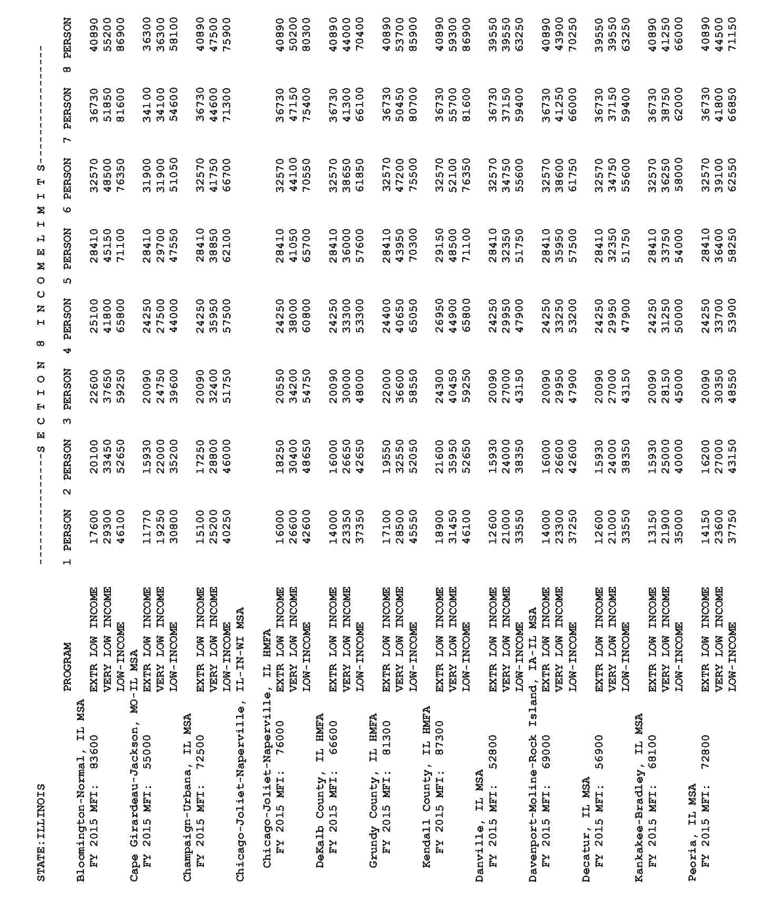
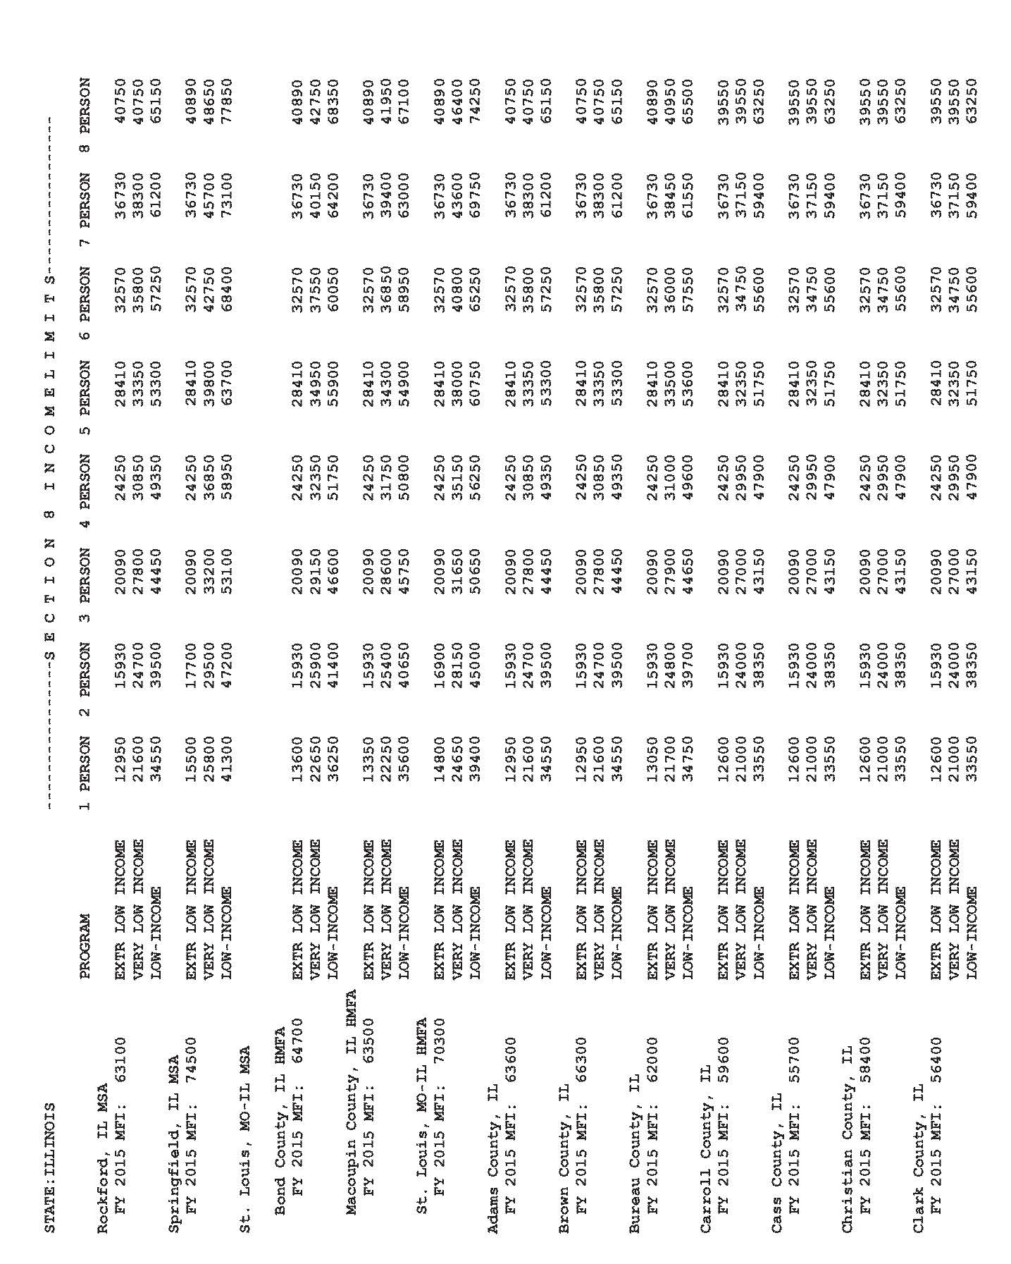
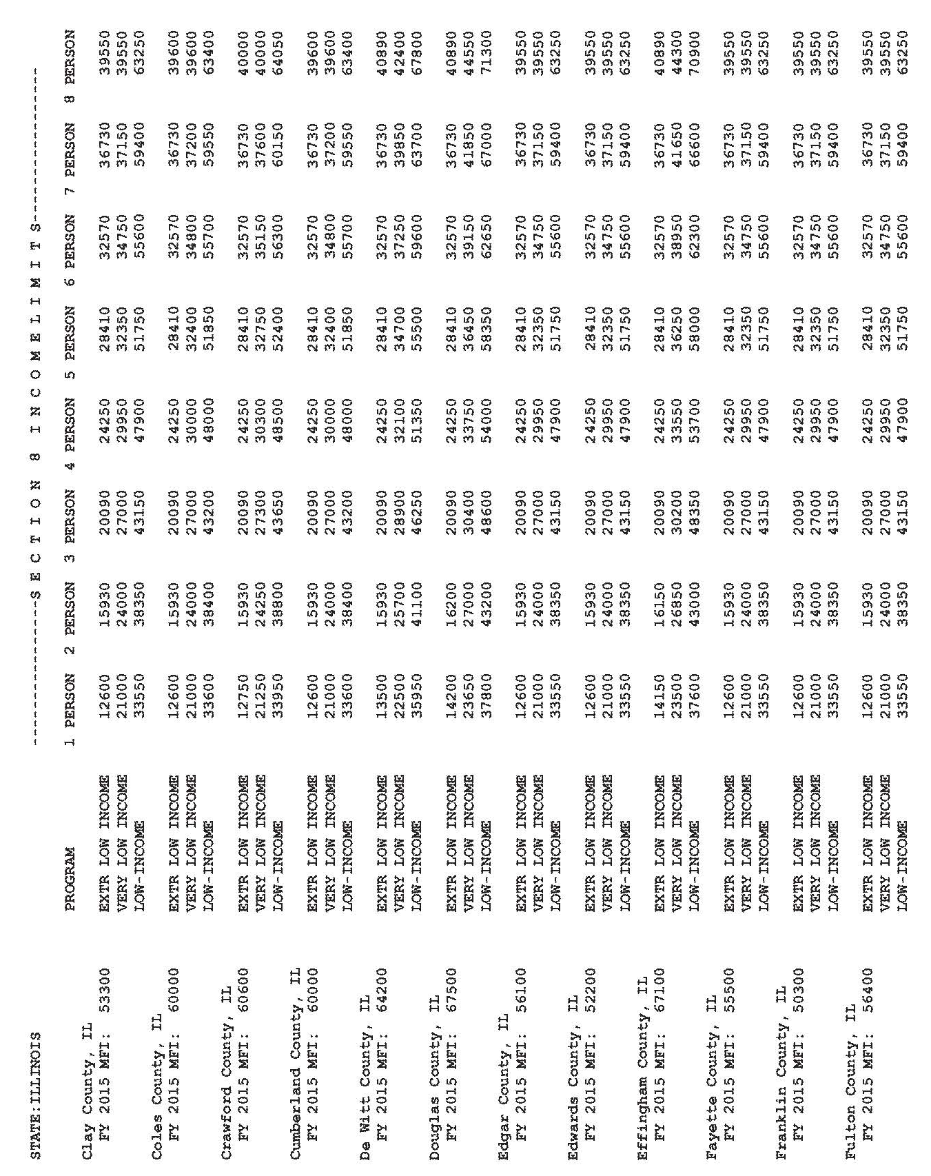
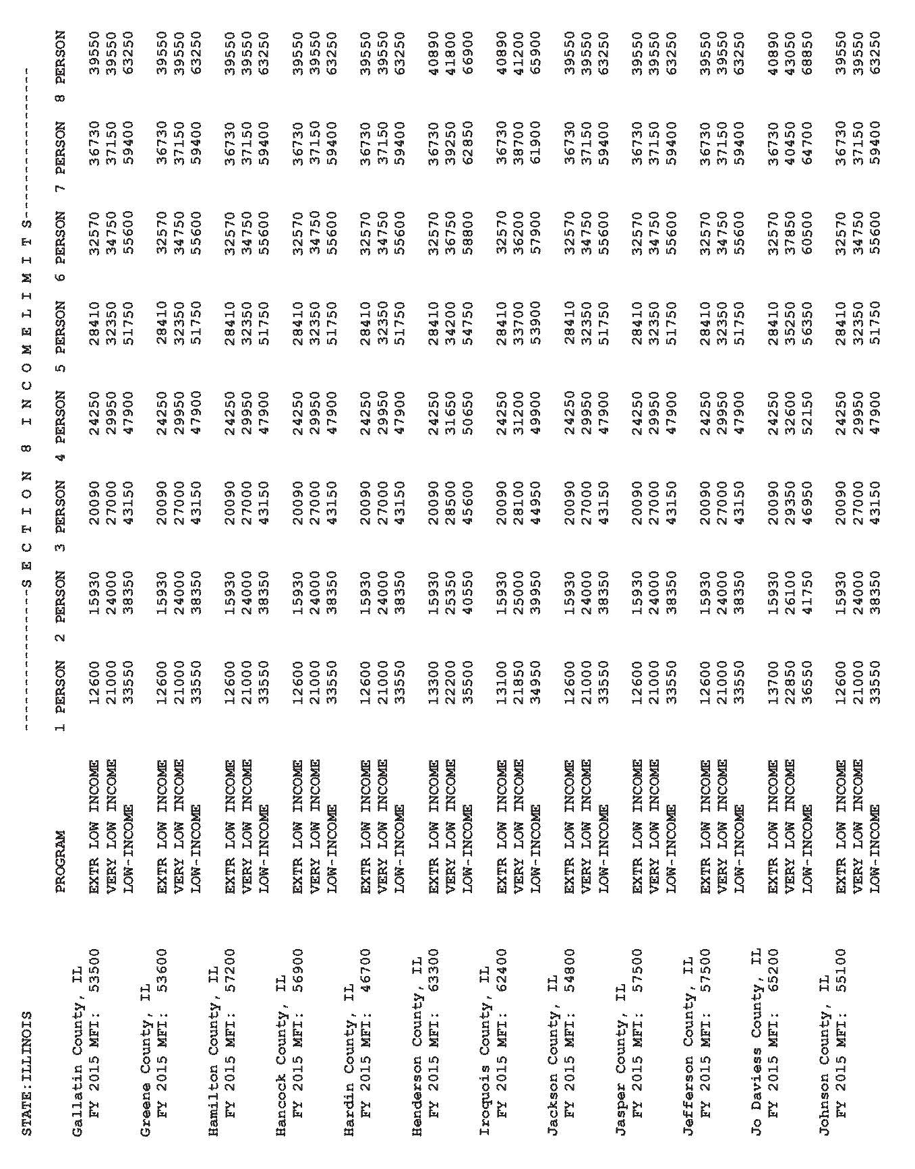
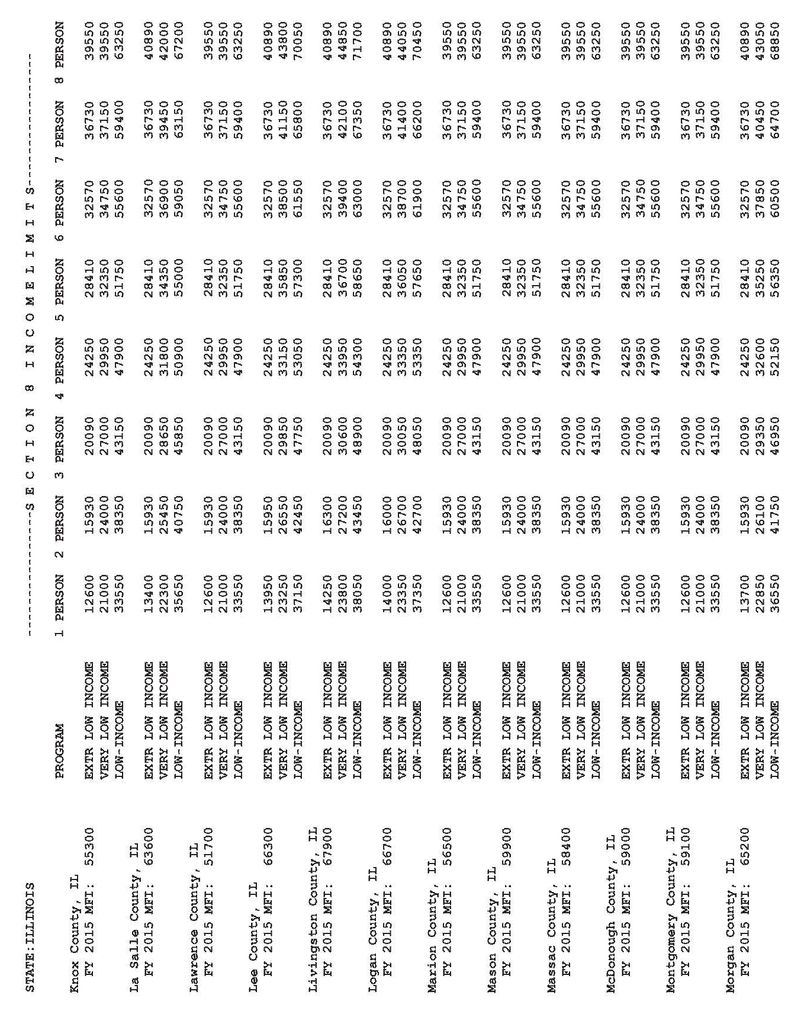
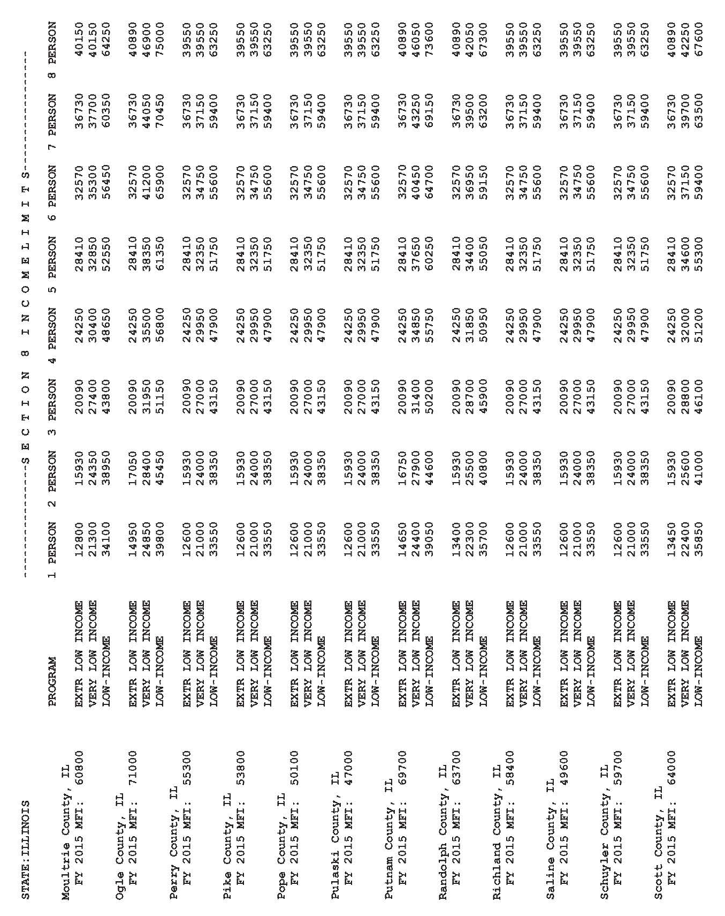
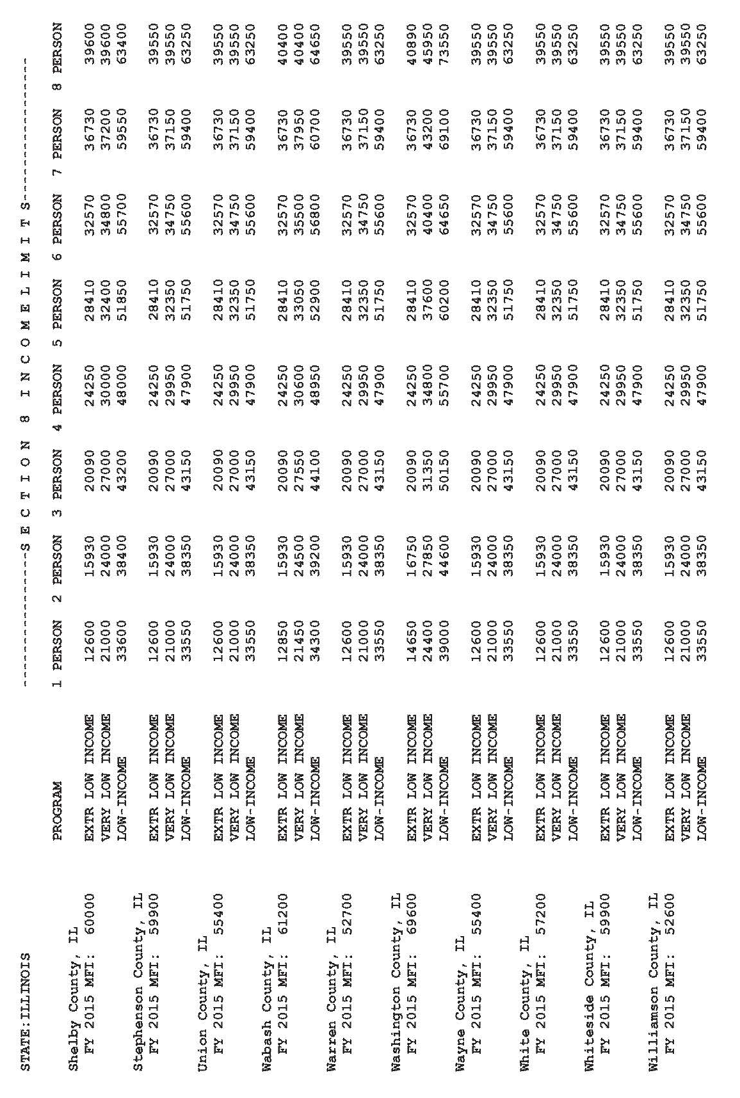
ATTACHMENT B

APPLICANT FINANCIAL INFORMATION

Please provide the following information relative to the project for which CDBG DR funds are being requested (please provide information for all public infrastructure projects)
Total Project Cost | $
CDBG PI Grant Requested | $
Total # of Persons Served | $

Current Average Monthly Residential Water and Sewer Bills (Attach copies of current water & wastewater rate schedules)
Water Charge | $ |  | /5,000 gallons
Sewer Charge | $ |  | /5,000 gallons
(If water/sewer billed in cubic feet, provide the cost based upon 669 cubic feet.)

Provide dates of most recent rate changes

Most recent water rate change: __ /___/_____ Most recent sewer rate change: _/__/____

Projected monthly residential charge for 5,000 gallons of water and 5,000 gallons of sewage treatment if community proceeds with project without grant assistance
Water Charge | $ |  | /5,000 gallons
Sewer Charge | $ |  | /5,000 gallons

Other Financial Information
Equalized assessed valuation for 2014 |  | $
Municipal government tax rate in 2014:  (collectible in 2015) |  | $
Aggregate tax rate for all local taxing bodies (e.g., county, township, school district) in 2014: [Add total tax rate of each unit of local government levying property taxes within the project area (county, township, etc.)] (collectible in 2015) |  | $
Population according to 2010 Census Population
Current number of Water and Sewer Accounts
Total Water Accounts:
Total Sewer Accounts:
Residential Water Accounts:
Residential Sewer Accounts:
Total Amount of Cash Reserves | $
Cash reserves above designated for specific purposes:
 | $
 | $
 | $

ATTACHMENT C

Engineer’s Cost Estimate

All proposed project activities shall be accompanied by a detailed cost estimate prepared and signed by a Professional Engineer licensed in the State of Illinois. The cost estimate shall contain the cost of construction, engineering fees, and related costs. The construction estimate shall be a listing of construction items (as a bid proposal), estimated quantity, unit of measure, unit price, and amount.

Engineering fees shall be clearly identified by type in a line item format. Typical items include basic services, resident project representative, topographic surveying, property surveying, geotechnical investigation, and testing. Do not include contingencies, miscellaneous costs.

1. Construction Cost Details
Item Description | Estimate Quantity | Estimated Cost
 |  | $
 |  | $
 |  | $
 | Subtotal A | $

2. Professional Fees and Permits
 |  | Estimated Cost
Design Engineering |  | $
Construction Engineering |  | $
Permits/ Archeological Survey |  | $
Legal and Bonding Fees |  | $
Other (specify) |  | $
 | Subtotal B | $

3. Related Construction Costs
 |  | Estimated Cost
Real Property/ Easements/ Acquisition |  | $
Other (specify) |  | $
 | Subtotal C | $

4. Total Project Costs

Subtotal A + Subtotal B + Subtotal C = $ _________________ Total

Estimates prepared on ____/____/____ by __________________________________

Address/ Telephone: ____________________________________________________________________

Signature/ Date: ________________________________________________________________________

ATTACHMENT D

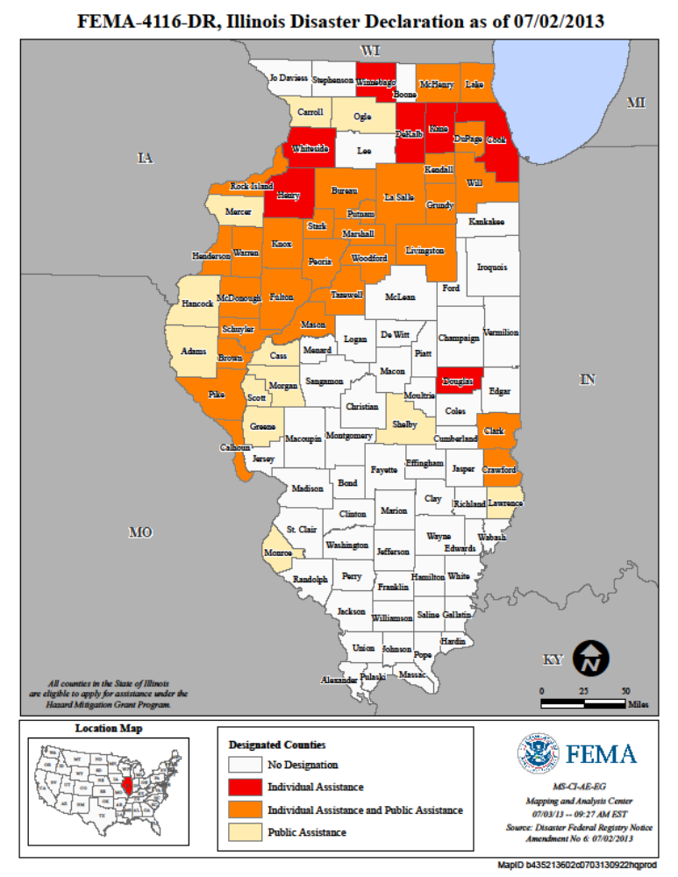

ATTACHMENT D, Continued

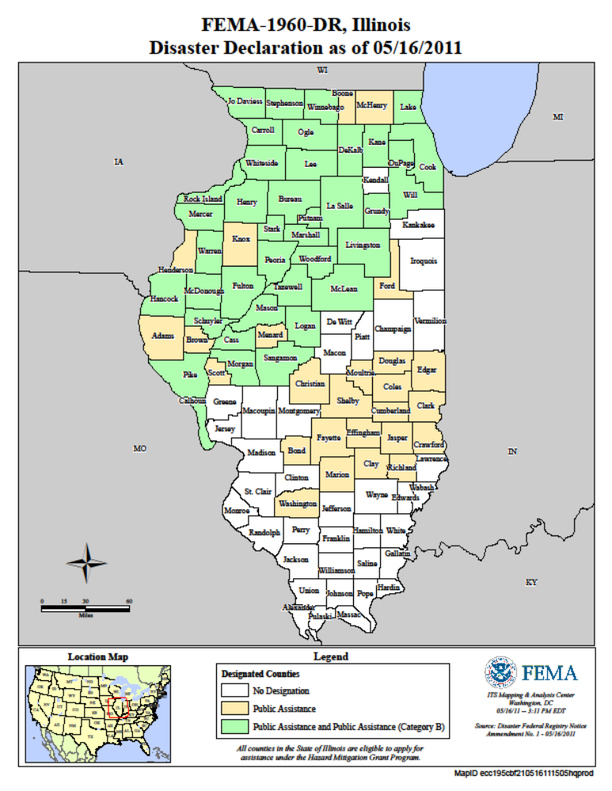

ATTACHMENT D, Continued

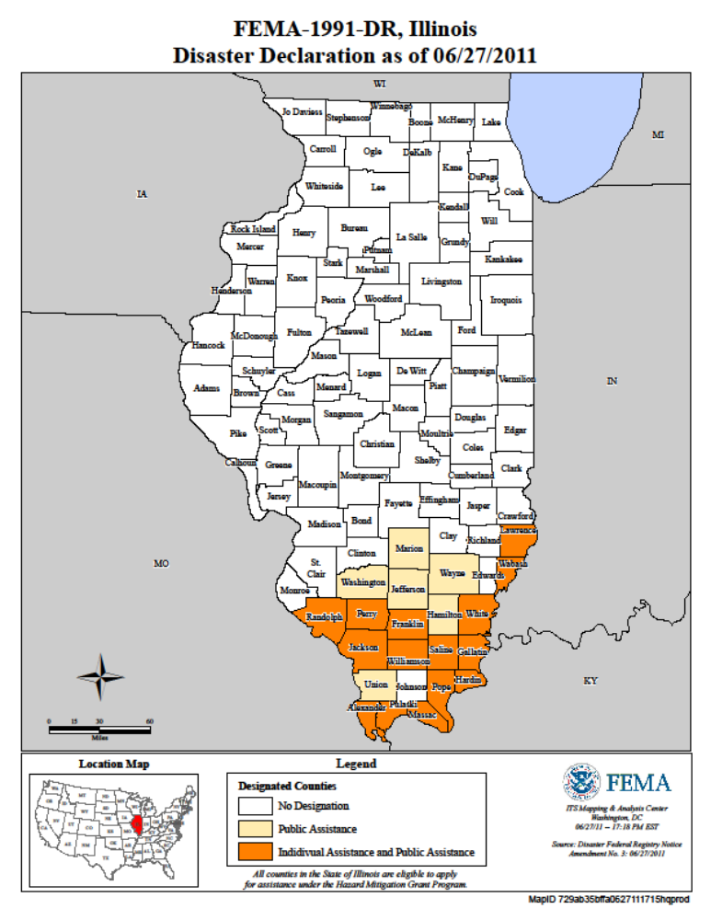
ATTACHMENT D, Continued

Federally-Designated Areas Eligible for CDBG-DR Assistance
The following Illinois counties were declared eligible for federal assistance in the four 2011-2013 Disaster Declarations:

Illinois Counties Declared Under FEMA-4116-DR

- Adams County | 21. Marshall County
- Brown County | 22. Mason County
- Bureau County | 23. McDonough County
- Calhoun County | 24. McHenry County
- Carroll County | 25. Mercer County
- Cass County | 26. Monroe County
- Clark County | 27. Morgan County
- Crawford County | 28. Ogle County
- DuPage County | 29. Peoria County
- Fulton County | 30. Pike County
- Greene County | 31. Putnam County
- Grundy County | 32. Rock Island County
- Hancock County | 33. Schuyler County
- Henderson County | 34. Scott County
- Kendall County | 35. Shelby County
- Knox County | 36. Stark County
- Lake County | 37. Tazewell County
- LaSalle County | 38. Warren County
- Lawrence County | 39. Will County
- Livingston County | 40. Woodford County

Illinois Counties Declared Under FEMA-1991-DR

1. Alexander County | 12. Pope County
2 Franklin County | 13. Pulaski County
3. Gallatin County | 14. Randolph County
4. Hamilton County | 15. Saline County
5. Hardin County | 16. Union County
6. Jackson County | 17. Wabash County
7. Jefferson County | 18. Washington County
8. Lawrence County | 19. Wayne County
9. Marion County | 20. White County
10. Massac County | 21. Williamson County
11. Perry County

ATTACHMENT D, Continued

Illinois Counties Declared Under FEMA-1960-DR

1. | Adams | 32. | Lake
2. | Bond | 33. | LaSalle
3. | Boone | 34. | Lee
4. | Brown | 35. | Livingston
5. | Bureau | 36. | Logan
6. | Calhoun | 37. | Marion
7. | Carroll | 38. | Marshall
8. | Cass | 39. | McDonough
9. | Christian | 40. | McHenry
10. | Clark | 41. | McLean
11. | Clay | 42. | Menard
12. | Coles | 43. | Mercer
13. | Cook | 44. | Morgan
14. | Crawford | 45. | Moultrie
15. | Cumberland | 46. | Ogle
16. | DeKalb | 47. | Peoria
17. | Douglas | 48. | Pike
18. | DuPage | 49. | Richland
19. | Edgar | 50. | Rock Island
20. | Effingham | 51. | Sangamon
21. | Fayette | 52. | Scott
22. | Ford | 53. | Shelby
23. | Fulton | 54. | Stark
24. | Grundy | 55. | Stephenson
25. | Hancock | 56. | Tazewell
26. | Henderson | 57. | Warren
27. | Henry | 58. | Washington
28. | Jasper | 59. | Whiteside
29. | Jo Daviess | 60. | Will
30. | Kane | 61. | Winnebago
31. | Knox | 62. | Woodford

ATTACHMENT E

Meeting and Documenting National Objectives

Before any activity can be funded in whole or in part with CDBG funds, a determination must be made as to whether the activity is eligible under Title I of the Housing and Community Development Act (HCDA), as amended. Activities must also meet one of the three national objectives. All projects funded under CDBG must address at least one of the following three national objectives of the CDBG Program:
- Benefit low- and moderate-income (LMI) persons (in accordance with HUD LMI standards);
- Aid in the prevention or elimination of slum and blight; or
- Meet other community development needs having a particular urgency.

Each grantee is required to select an applicable National Objective for each proposed project. Depending on the selected National Objective, varying documentation will be required to support the selection. A summary of the different national objective options available can be found within the sections below.

Section I - Benefit to Low-to-Moderate Income (LMI) Persons
Section II - Aid in the Prevention or Elimination of Slum and Blight (Slum/Blight)
Section III - Meets Community Development Needs Having a Particular Urgency (Urgent Need)

For additional details regarding the criteria, limitations, restrictions, and required documentation for each national objective, please see 24 CFR 570.483 and HUD’s “Guide to National Objectives and Eligible Activities for State CDBG Program.”

Section I - Benefit to Low-to-Moderate Income (LMI) Persons

The Housing Community Development Act (HCDA) defines the term ‘low-and moderate income persons’ as families and individuals whose incomes are no more than 80 percent of the median income of the area involved. The ‘area involved’ is the geographic area where all the people benefiting from the project reside. The 80% of median income figure is determined by HUD based on a four-person family and is adjusted upward or downward for larger or smaller families.

The criteria for how an activity may be considered to benefit LMI persons are divided into four subcategories:
- Those based on Area Benefit;
- Those serving a Limited Clientele;
- Those involving Housing; and
- Those involving Employment (Jobs).

- LMI Area Benefit: An activity that is available to benefit all the residents of an area that is primarily residential may qualify as a LMI Area Benefit national objective. In order to qualify as addressing the national objective of benefit to LMI persons on an area basis, an activity must meet the identified needs of LMI persons residing in an area where at least 51 percent of the residents are LMI persons. The benefits of this type of activity are available to all residents in the area regardless of income.

For each activity determined to benefit low- and moderate-income persons based on the area served by the activity, the following documentation is required in the application:
- Boundaries of the service area
- Census data including total persons and percentage of LMI persons
- Evidence that the area is primarily residential
- If an income survey is used instead of census data, survey documentation must be provided as support.

- LMI Limited Clientele: An activity that provides benefits to a specific group of persons meeting or presumed to meet LMI standards rather than everyone in an area may qualify as a LMI Limited Clientele national objective. These activities may benefit particular persons without regard to the area in which they reside, or may be activities that provide benefit on an area basis but only to a specific group of persons who reside in the area. In either case, at least 51 percent of the beneficiaries of the activity must be LMI persons.

It should be noted, however, that, because of certain statutory limitations, the regulations preclude the following kinds of activities from qualifying under this subcategory:
- Activities involving the acquisition, construction, or rehabilitation of property for housing, including homeownership assistance (these must qualify under the LMI Housing subcategory); or
- Activities where the benefit to LMI persons is the creation or retention of jobs (these must qualify under the LMI Jobs subcategory (with certain exceptions).

An activity must meet one of the following requirements in order to qualify as a LMI Limited Clientele activity:
- The activity must exclusively benefit a clientele who are generally presumed by HUD to be principally LMI persons. The following groups are currently presumed by HUD to be made up principally of LMI persons:
  - Abused children,
  - Elderly persons,
  - Battered spouses,
  - Homeless persons,
  - Adults meeting Bureau of Census’ definition of severely disabled adults,
  - Illiterate adults,
  - Persons living with the disease AIDS, and
  - Migrant farm workers;
- The Grantee must require information on family size and income so that it is evident that at least 51 percent of the clientele are persons whose family income does not exceed the low and moderate income limit;
- The activity must have income eligibility requirements which limit the activity exclusively to low and moderate income persons;
- The activity must be of such a nature, and be in such a location, that it may be concluded that the activity's clientele will primarily be low-and moderate income persons; or
- An activity that serves to remove material or architectural barriers to the mobility or accessibility of elderly persons or of adults meeting the Bureau of the Census' Current Population Reports definition of "severely disabled" will be presumed to qualify under this criterion if it is restricted, to the extent practicable, to the removal of such barriers (and the activity does not qualify under another option).

Grantees implementing projects that meet the LMI Limited Clientele national objective must provide sufficient documentation within the application indicating that the beneficiaries are LMI or are presumed to be LMI. For activities that provide benefit to LMI beneficiaries, the grantee must retain (and provide upon request) the income verification documentation for all applicable beneficiaries.

- LMI Housing: An activity that assists in the acquisition, construction, or improvement of permanent, residential structures may qualify as a LMI Housing national objective only to the extent that the housing is occupied by LMI persons. (This includes activities directed towards homeownership assistance.) In order for such activities to qualify under the LMI Housing national objective, it must result in housing that will be occupied by LMI households upon completion. The housing can be either owner- or renter-occupied and can be either one family or multi-unit structures. When the housing is to be rented, in order for a dwelling unit to be considered to benefit a LMI household, it must be occupied by the household at affordable rents. The grant recipient is responsible for establishing the criteria it will use to determine rent affordability for this purpose and must make these criteria public. Note that LMI Housing is based on households and not persons.

Grantees implementing housing projects that meet the LMI Housing national objective must consider the following requirements:

- For each multi-family rehabilitation activity determined to benefit low- and moderate-income persons, the grantee must provide documentation in the application indicating that they have:
- Established (and published) a local definition of "affordable rents” for LMI households consistent with state standards.
- A system to monitor the rent charged (or to be charged) after rehabilitation, for each dwelling unit in each structure rehabilitated.
- An estimate of the total number of dwelling units rehabilitated in each structure and the percent of units in each structure which are to be occupied by low- and moderate-income households.
- For single family rehabilitation:
- An estimate of the number of units to be rehabilitated.
- Income characteristics of the area in which the rehabilitation is to be carried out.
- Number of units to be rehabilitated for low- and moderate income households.
- Amount to be spent on each unit to be rehabilitated for low- and moderate-income households.

In addition to the documentation required during the application process, grantees must require and retain income documentation from LMI beneficiaries occupying CDBG-assisted residential units.

- LMI Jobs: A LMI Jobs activity is one which creates or retains permanent jobs, at least 51 percent of which, on a full time equivalent (FTE) basis, are either held by LMI persons or considered to be available to LMI persons.

In counting the jobs to be used in the calculation for determining the percentage that benefit LMI persons, the following policies apply:
- Part-time jobs must be converted to full-time equivalents (FTE) (for example, a job that will require only working half time would count as only one-half a job);
- Only permanent jobs count; temporary jobs may not be included;
- Seasonal jobs are considered to be permanent for this purpose only if the season is long enough for the job to be considered as the employee’s principal occupation;
- All permanent jobs created or retained by the activity must be counted even if the activity has multiple sources of funds; and
- Jobs indirectly created or retained by an assisted activity (i.e., “spin off” jobs) may not be counted (for example, jobs created by an unrelated company which supplies parts to the manufacturing firm being assisted).

Grantees implementing projects that propose to meet the LMI Jobs national objective must consider the following requirements:
- For job creation:
- When demonstrating that at least 51 percent of the jobs created will be available to LMI persons, documentation for each assisted business must include:
    - A written commitment by the business that it will make at least 51 percent of the jobs on a full time equivalent basis available to LMI persons and will provide training for any of those jobs requiring special skills or education.
    - A listing by job title of employees at the time the application for assistance is submitted.
    - A listing, by job title, of the total permanent jobs to be created, indicating which jobs will be available to LMI persons, which jobs require special skills or education, and which jobs are part-time.
    - Evidence supporting the estimate of the total number of jobs.
    - A description of actions to be taken by the recipient and business to ensure that LMI persons will receive first consideration for these jobs.
    - A listing, by job title, race, ethnicity, gender and handicapped status of the permanent jobs created, and which jobs were made available to LMI persons, and a description of how first consideration was given to such persons for those jobs. That description should include the hiring process used; the number of LMI persons considered for each job; and the number of LMI persons actually hired.
    - A description of how the LMI status of those given first consideration was determined.
    - A description of how, the total number of jobs was determined.
- When demonstrating that at least 51 percent of the jobs will be taken by LMI persons, documentation for each assisted business must include:
- A written commitment by the business that at least 51 percent of the jobs, on a full-time equivalent basis, will be held by LMI persons.
- A listing, by job title, of employees at the time the application for assistance is submitted.
- A listing, by job title, of the permanent jobs to be created.
- Evidence supporting the estimated total number of jobs to be created.
- A listing, by job title, race, ethnicity, gender and handicapped status of the permanent jobs actually created and those initially taken by LMI persons.
- A description of how the LMI status of those hired was determined by the grantee during the review of the recipient.
- A description of how the total number of jobs was determined.

- For job retention:
- Clear and objective evidence that in the absence of the CDBG assistance the jobs will be lost.
- A written commitment by the business to meet the standard for retained jobs involving the employment of LMI persons.
- A listing by job title, race, ethnicity, gender and handicapped status of the employees at the time the assistance is provided.
- A written commitment by the business to meet the standard for retained jobs involving the employment of low- and moderate income persons.
- A listing by job title, race, ethnicity, gender and handicapped status of the employees at the time the assistance is provided.
- A listing of each job which has turned over to date, indicating which of those jobs were either taken by, or made available to, low- and moderate-income persons.
- A description of how first consideration was given to persons for whom the job was made available (consistent with the "available to" standard).
- A description covering the items identified above as necessary in demonstrating the "taken by" standard.
- A description of how the state determined jobs were held by, made available to, or taken by low- and moderate-income persons.

Section II - Aid in the Prevention or Elimination of Slum and Blight (Slum/Blight)

In developing the criteria for qualifying under this national objective, HUD has taken considerable care to ensure that activities that qualify under the objective are either clearly eliminating objectively determinable signs of slum and blight in a defined Slum or Blighted Area or are strictly limited to eliminating specific instances of blight outside such an area (Spot Blight)

An activity may be considered to aid in the prevention or elimination of slum and blight in two distinct ways:
- Addressing slums/blight on an area basis, and
- Addressing slums/blight on a spot basis.

- Slum/Blight Area Basis: To qualify under the national objective of slums/blight on an area basis, an activity must meet all of the following criteria:
- The area must be officially designated by the grant recipient and must meet a definition of a slum, blighted, deteriorated, or deteriorating area under State or local law. (For these purposes, it is not necessary to formally designate/declare the area to be blighted, but the area must meet the definitions for designation.)
- The area must exhibit at least one of the following physical signs of blight or decay:
- There must be a substantial number of deteriorated or deteriorating buildings throughout the area. As a “safe harbor,” HUD will consider this test to have been met if either:
- The proportion of buildings in the area that are in such condition is at least equal to that specified in the applicable State law for this purpose; or
- In the case where the applicable State law does not specify the percentage of deteriorated or deteriorating buildings required to qualify the area, then at least one quarter of all the buildings in the area must be deteriorated or deteriorating; or
- The public improvements throughout the area must be in a general state of deterioration. (For this purpose, it would be insufficient for only one type of public improvement, such as a sewer system, to be in a state of deterioration; rather, the public improvements taken as a whole must clearly exhibit signs of deterioration.)
- Documentation must be maintained by the grant recipient on the boundaries of the area and the conditions that qualified the area at the time of its designation.
- Activities to be assisted with CDBG funds must be limited to those that address one or more of the conditions that contributed to the deterioration of the area. (Note that this does not limit the activities to those that address the blight or decay itself, but it allows an activity to qualify if it can be shown to address a condition that is deemed to have contributed to the decline of the area.)

Where the assisted activity is rehabilitation of residential structures, two additional criteria must be met:
- Each such building must be considered substandard under local definition. (States are to ensure that state grant recipients have developed minimum building quality standards for this purpose. Local conditions may be taken into consideration; states are also free to set standards regarding building quality.)
- All deficiencies making the building substandard must be corrected before less critical work on the building may be undertaken.

Grantees implementing projects meeting the Slum/Blight Area Basis national objective must provide the following documentation in the application:
- The boundaries of the area (as delineated by the unit of general local government);
- A description of the conditions which qualifies the area as a slum or blighted area under state or local law;
- A resolution by the applicable local government indicating that the area qualifies as a slum or blighted area under state or local law;
- Documentation that throughout the area there is a substantial number of deteriorated or deteriorating buildings or the public improvements are in a general state of deterioration (this requirement may be met by providing photographs, structural surveys, and/or development plans associated with the area);
- A description of how the assisted activity addresses one or more of the conditions which contributed to the deterioration of the area. Rehabilitation of residential buildings carried out in an area meeting the above requirements will be considered to address the area's deterioration only where each such building rehabilitated is considered substandard before rehabilitation, and all deficiencies making a building substandard (local government must adopt a definition of ‘substandard’) have been eliminated if less critical work on the building is also undertaken; and
- The grantee keeps records sufficient to document its findings that a project meets the national objective of prevention or elimination of slums and blight.

- Slum/Blight Spot Basis: The elimination of specific conditions of blight or deterioration on a spot basis is designed to comply with the statutory objective for CDBG funds to be used for the prevention of blight, on the premise that such action(s) serves to prevent the spread to adjacent properties or areas.

To comply with the national objective of Elimination or Prevention of Slum and Blight on a Spot Basis, i.e., outside a slum or blighted area, an activity must meet the following criteria:
- The activity must be designed to eliminate specific conditions of blight or physical decay, not be located in a designated slum or blighted area; and
- The activity must be limited to one of the following:
- Acquisition;
- Clearance;
- Relocation;
- Historic Preservation; or
- Rehabilitation of buildings, but only to the extent necessary to eliminate specific conditions detrimental to public health and safety.
The following documentation must be provided in the application in order to meet this national objective:
- Sufficient evidence (photos, surveys, etc.) demonstrating that the targeted structure meets the definition of a blighted (decrepit, desolate, and/or in disrepair) structure;
- Justification as to how the blighted structure poses a threat to public health and safety; and
- A description of how the proposed activities will alleviate the threats to public health and safety.

Section III - Meets Community Development Needs Having a Particular Urgency (Urgent Need)

To comply with the national objective of meeting community development needs having a particular urgency, an activity must be designed to alleviate existing conditions which the local government certifies and state determines:
- Pose a serious and immediate threat to the health or welfare of the community;
- Are of recent origin or recently became urgent;
- The state grant recipient is unable to finance the activity on its own; and
- Other sources of funding are not available to carry out. A condition will generally be considered to be of recent origin if it developed or became critical within 18 months preceding the state grant recipient’s certification.

In order to meet the Urgent Need national objective requirements, a grantee must provide:
- Documentation of urgency of need and timing; and
- Certification (resolution) by the grantee that the activities meet all the applicable criteria above.

