
2024 National Black Business Month Toolkit
Empowering Excellence: Proudly Celebrating National Black Business Month in Illinois

This August, the Illinois Department of Commerce and Economic Opportunity (DCEO) is celebrating National Black Business Month. Through the Office of Minority Economic Empowerment (OMEE), DCEO will host a series of virtual and in-person events highlighting Black businesses, organizations, and community leaders while also providing resources to Black businesses and entrepreneurs. This monthlong celebration will also include a social media campaign inviting and encouraging Illinoisans to shop Black-owned businesses through the “Shop Black Saturdays” social media campaign.
Below you will find tips, sample social media posts, graphics, and ideas on how to celebrate and promote Black Business Month!

SOCIAL MEDIA TIPS:
- Be sure to use the official hashtags in order amplify the movement:
  - #ILBlackBizMonth
  - #ShopBlackSaturday
- Follow, Tag & RT DCEO and your favorite Black-owned businesses to show support:
  - DCEO Handle: @IllinoisDCEO
  - DCEO Facebook
  - DCEO Twitter
  - DCEO LinkedIn

- Use visuals like the provided graphics or a photo of you at your favorite Black-owned business
- Link to DCEO’s Black Business Month landing page for events and resources - https://bit.ly/4fkztIx
- Make it your own! Tailor content to your stakeholders.

LINKS AND RESOURCES:
- Resources for Illinois Black-owned businesses
  - Illinois Office of Minority Economic Empowerment (OMEE)

- List of Illinois’ Black-Owned Businesses
  - Meet Black Illinois Makers

- Resources for supporting Black Businesses
  - Chicago
  - Peoria
  - Kendall, DuPage, Kane and Will Counties
  - Southern Illinois

SAMPLE SOCIAL MEDIA POSTS:

Twitter Post #1: (General Black Business Month Post)
Black businesses & entrepreneurs are foundational to Illinois’ economy. Join DCEO as we celebrate National Black Business Month by:

✅ Attending DCEO's events
✅ Shopping Black-Owned Businesses
✅ Spreading the word using #ILBlackBizMonth

Get involved - https://bit.ly/4fkztIx
Twitter Post #2: (General #ShopBlackSaturday Post)
Join @illinoisDCEO in celebrating National Black Business Month! Attend one of DCEO’s events and join in on the #ShopBlackSaturday campaign to uplift and support the extraordinary Black businesses across Illinois. - https://bit.ly/4fkztIx #ILBlackBizMonth

Twitter: Post #3 (#ShopBlackSaturday Business Shout Out)
Stopped by [INSERT BUSINESS HANDLE] to celebrate #ILBlackBizMonth! Make sure to drop in and try their [EXAMPLES: Delicious food, unique clothes, best car wash in town, etc.].

Facebook/LinkedIn: Post #1 (General Black Business Month Post)
Tell us about your favorite Black-owned business! During #ILBlackBizMonth, promote their great products, services, and contributions to the community. Snap a pic and share using the hashtag #ShopBlackSaturday to spread the word. Learn more about what DCEO is doing to celebrate National Black Business Month and how to get involved by visiting - https://bit.ly/4fkztIx

Facebook/LinkedIn: Post #2 (#ShopBlackSaturday Business Shout Out)
During #ILBlackBiz Month we’re highlighting one of our favorite local businesses, [INSERT BUSINESS TAG] on #ShopBlackSaturday! Shout them out on social media & drop by for [EXAMPLES: Delicious food, unique clothes, the best car wash in town, etc].

SAMPLE NEWSLETTER/EBLAST:

Celebrate National Black Business Month this August!
During August, the Illinois Department of Commerce and Economic Opportunity (DCEO) is celebrating National Black Business Month. Throughout this monthlong celebration, DCEO, through its office of Office of Minority Economic Empowerment (OMEE), will be uplifting Black businesses and entrepreneurs across Illinois through a series of events and their “Shop Black Saturdays” social media campaign. Black businesses and entrepreneurs are foundational to our state’s economy, and they enrich our everyday lives. DCEO is committed to supporting Black business year-round. Make sure to visit the DCEO website for more information on resources and events.

GRAPHICS/IMAGES:
Below is a collection of graphics for social media/e-blasts. Simply right click and “save as picture” to use.
Facebook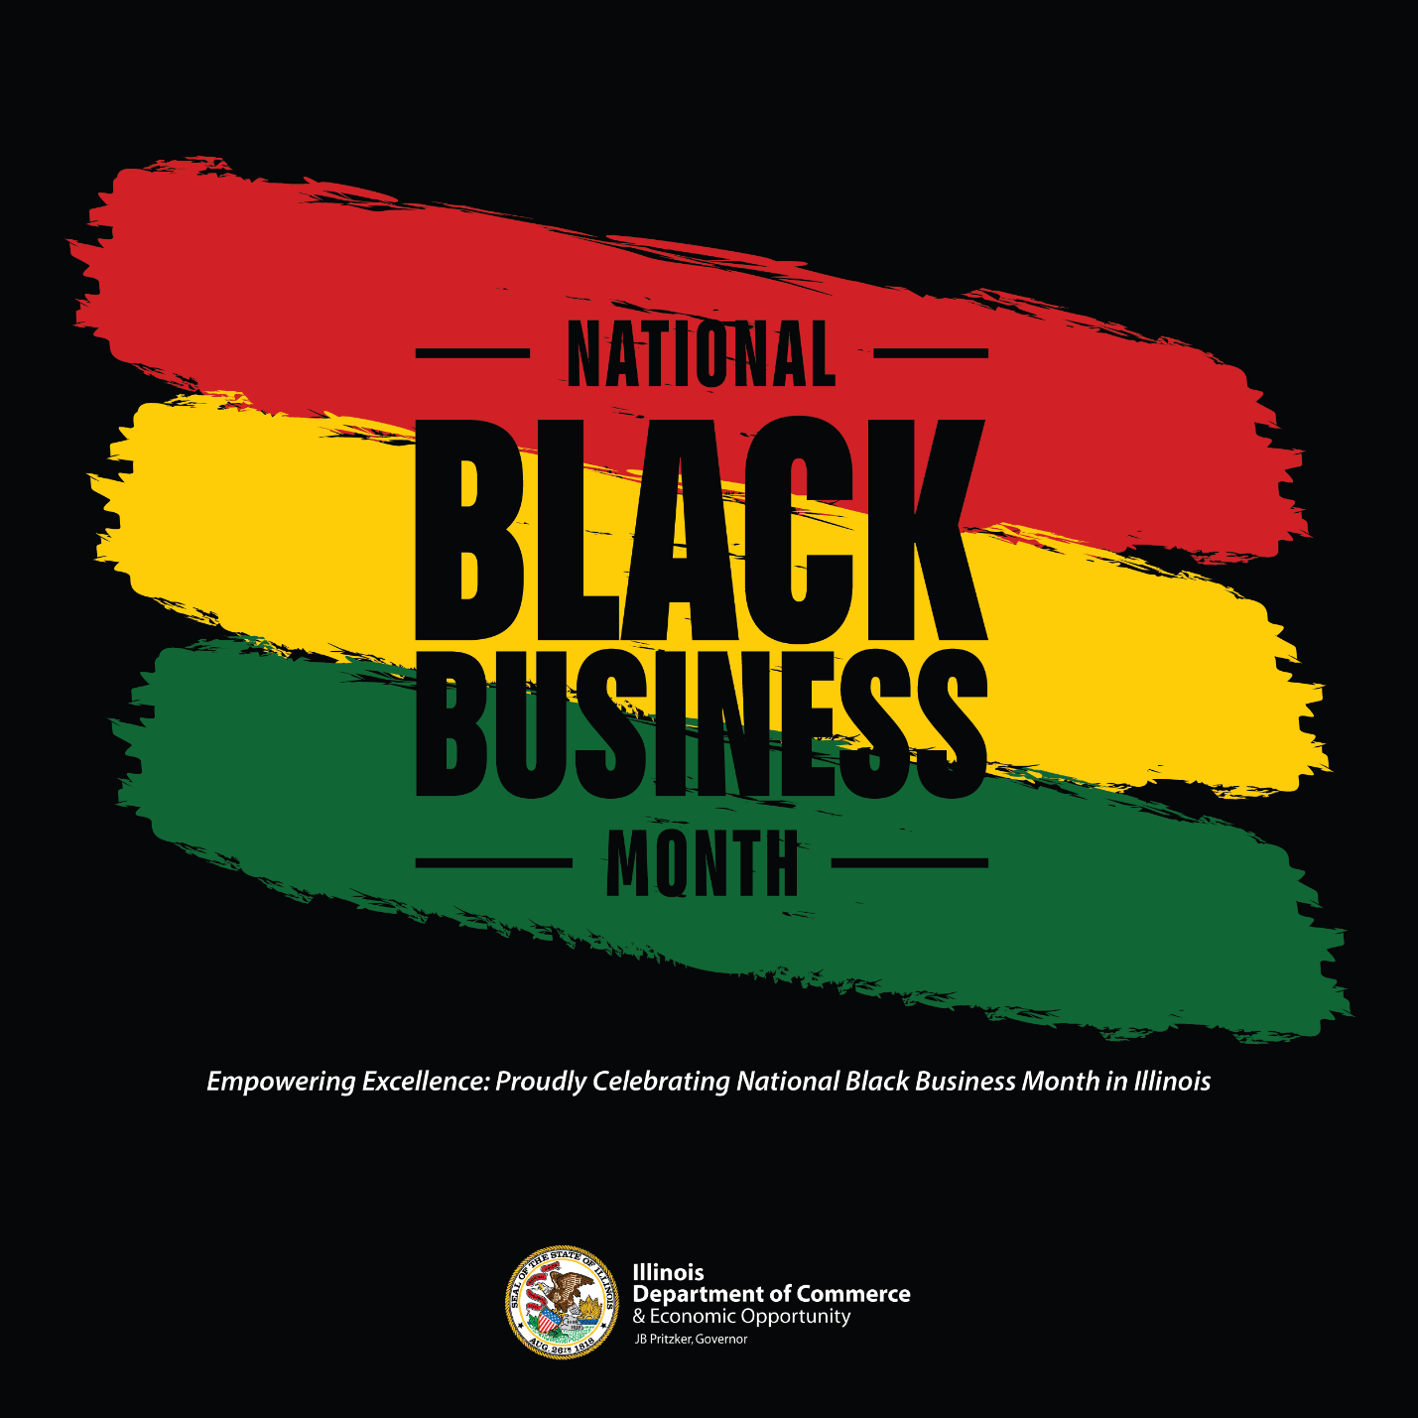

Twitter
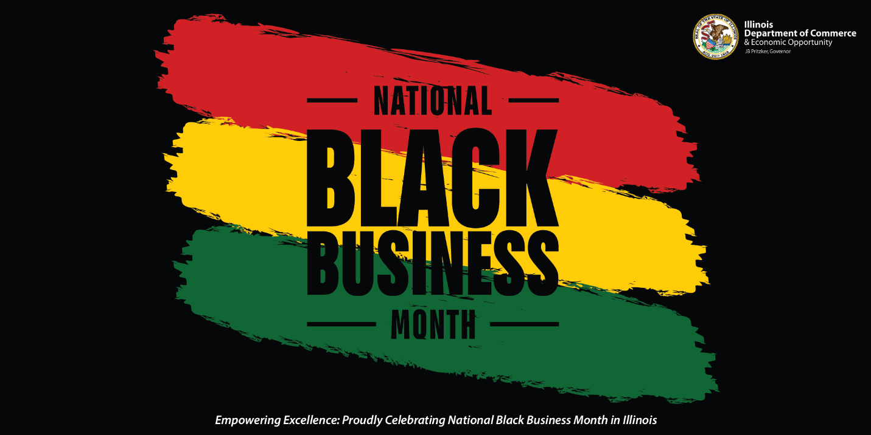
LinkedIn 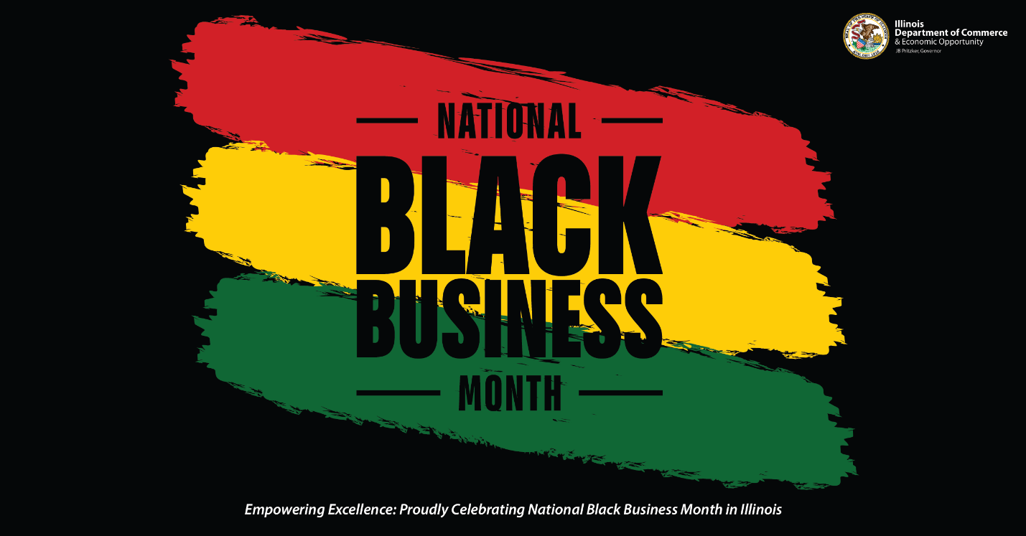
Shop Black Saturdays

Facebook
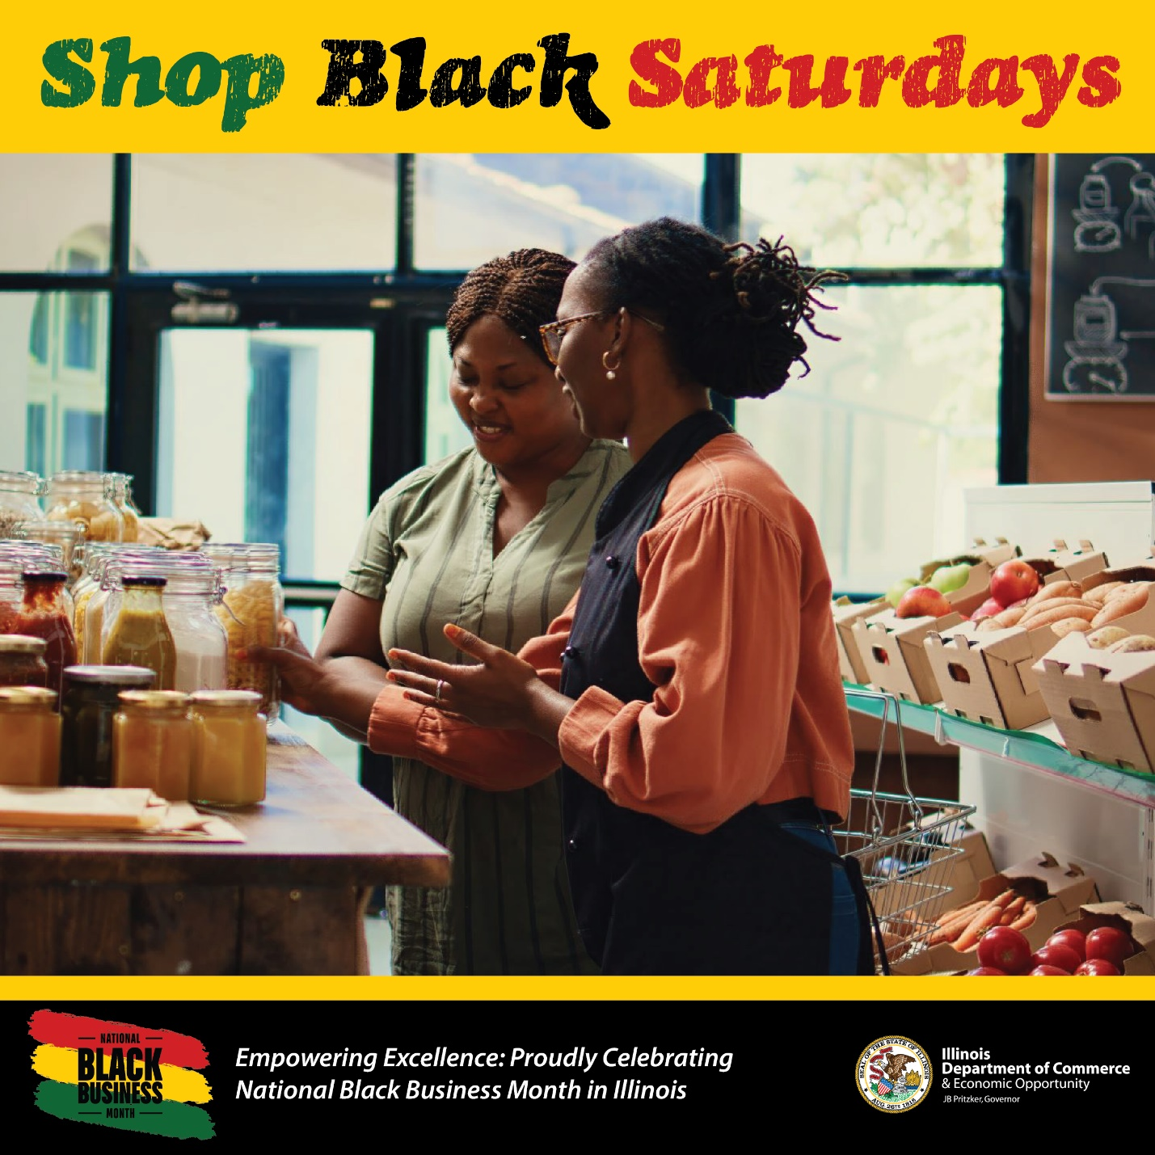
Twitter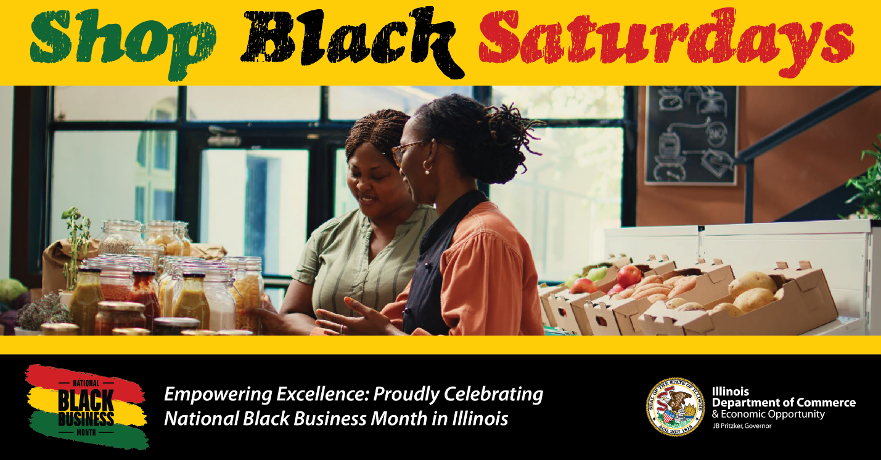

LinkedIn
